Linear Equations Quiz

- Determine and write the linear equation for a line that will safely pass through the gates below.
Draw the line.
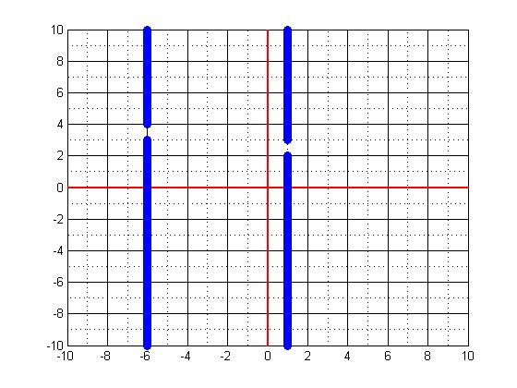

- What benefits does modeling in engineering provide?

