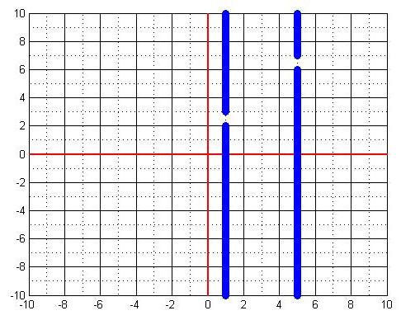
Game 1 Example

You can always try to guess the equation that will get you through the gates, but our goal as engineers with real-world challenges to solve is to learn how we can figure out the exact solution and get it right on the first try! We know that the slope of a straight line can be calculated as:
m=$\frac{y2-y1}{x2-x1}$
which some of you may know as rise (increase in y) over run (increase in x). This is very important because, using this equation, we can easily figure out the slope we need in order to get through the gates. In order to do so, we must pick two points of interest. Picking two points located in the middle of both gates identifies a line that gets us through both gates, and then we can calculate the slope of that line.
point 1 = (1,2.5) point 2= (5,6.5)
Thus, m=$\frac{6.5-2.5}{5-1}$ =$\frac{4}{4}$=1. To find the required b (y-intercept), we must choose one of the points of interest, since it will be located on the line we are defining. We can now take the slope (m) that we calculated and the chosen point and plug it into the standard equation:
y=mx+b
We can use the (x, y) coordinates of either known points, since the line will pass thorough them both. In this example, you may use y=2.5 and x=1 (center of left gate) or y=6.5 and x=5 (center of right gate). Both should give you the same result for b (the y-intercept)
1) 2.5=1(1) + b 2) 6.5=1(5) + b
if we solve for b, we get b=1.5, so our linear equation is y=1x+1.5.
Before you report your m and b values, double check by plugging in the x for one of the gates and see if the y ends up in the gate.

