Conductivity Meter
Building and Calibration Instructions

Materials List
- BASIC Stamp Activity Kit - Serial + USB (Text v.3.0) ($50, includes the HomeWork Board with a built-in BASIC Stamp 2 microcontroller, LEDs, wires, resistors and capacitors; item code 90005, available from parallax.com)
- computer (system requirements for PC: Pentium 133 mhz or higher, 32 MB RAM, VGA display; for MAC: G3 or higher with 64 MB RAM, color display)
- BASIC Stamp editor software (latest version for your operating system, free download available from Parallax Inc at http://www.parallax.com/Support/DownloadsPress/tabid/477/Default.aspx)
- (5) 550 Ω resistors (included in BASIC Stamp Activity Kit)
- 20 kΩ resistor (included in BASIC Stamp Activity Kit)
- 1 μF capacitor (included in BASIC Stamp Activity Kit)
- 22 AWG wire (included in BASIC Stamp Activity Kit)
- (5) LEDs, any color (included in BASIC Stamp Activity Kit)
- 555 Timer IC CMOS ($2 each, item code: 604-00009; available from parallax.com)
- (2) 5-inch 4/40 stainless steel screws
- (4) 4/40 nylon nuts
- roll of electrical tape
- hack saw
- Fisherbrand® SureOne™ pipette tip rack (100µl–1000µl size) (This is the empty container that is usually thrown out once all the tips are used. For this activity, it serves as a neat and tidy housing for the circuitry. As such, it is difficult to put a price on it; a case of these tips costs $65 and includes 10 racks.)
- BD Falcon 50 ml Conical Centrifuge Tubes with screw caps ($337 per case of 500, catalog number: 14-432-24; available from Fisher Scientific [www.fishersci.com])
- (4) zip ties
- drill, to make two holes in the cap

Building Instructions
- As shown in Figure 1, connect the BASIC Stamp module (1) to the Board of Education. Also plug in the serial cable (2), and the AC wall adapter (3) or the battery (4). The reset switch is the round button in the middle of the board, directly above the three-position switch.
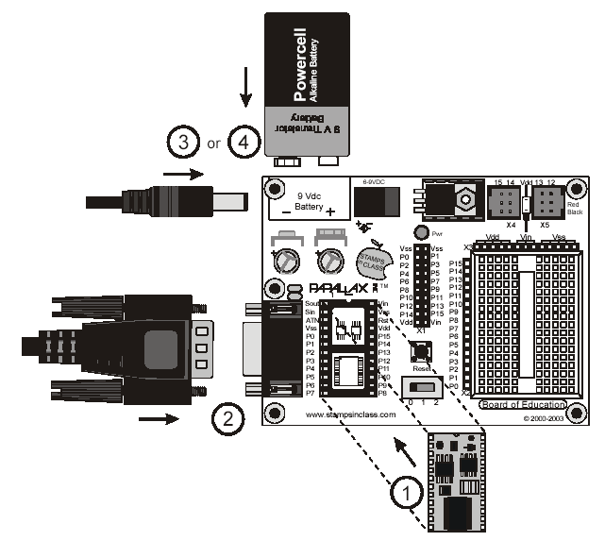
battery
⬇ board of education
reset button
serial cable
BASIC Stamp module ➔
AC wall adapter
three-position switch

Figure 1. Put together the BASIC Stamp module, the Board of Education, the serial cable
and the AC wall adapter or battery.

- Attach the 555 timer, resistors and capacitors to the corresponding pins on the Board of Education, as shown in Figure 2.
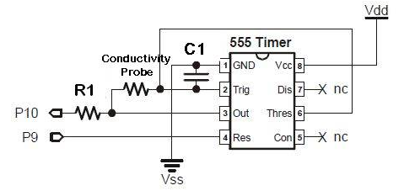

Figure 2. Attachment of the 555 timer to the Board of Education.
The conductivity probe is configured as a resistor.

- Connect the LEDs to the corresponding pins on the Board of Education (see Figure 3).
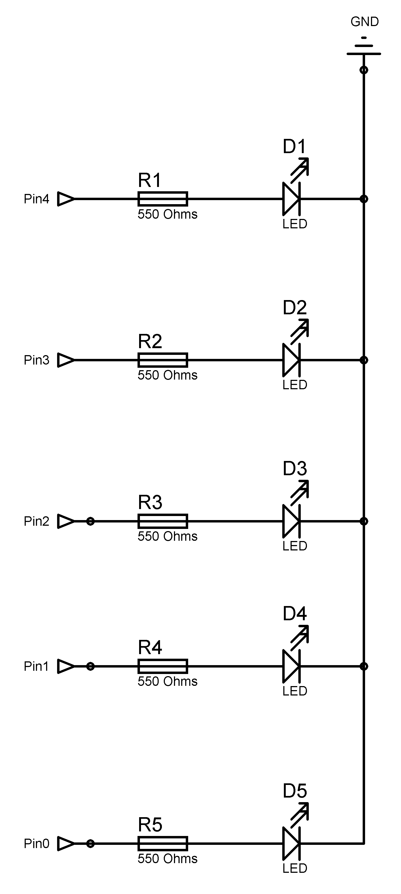
- Secure the Board of Education to the pipette tip box (zip ties work well for this).
- Attach the conductivity probe to the Board of Education. Wrap the ends of the jumper wires around the base of the screw head, and space them approximately 1 inch apart. Lock the screws in place using 2 4/40 nylon nuts. Connect the conductivity probe to the 555 timer, as shown in Figure 2.

Figure 3. Connection of LEDs to the Board of
Education using the 550 ohm resistors.

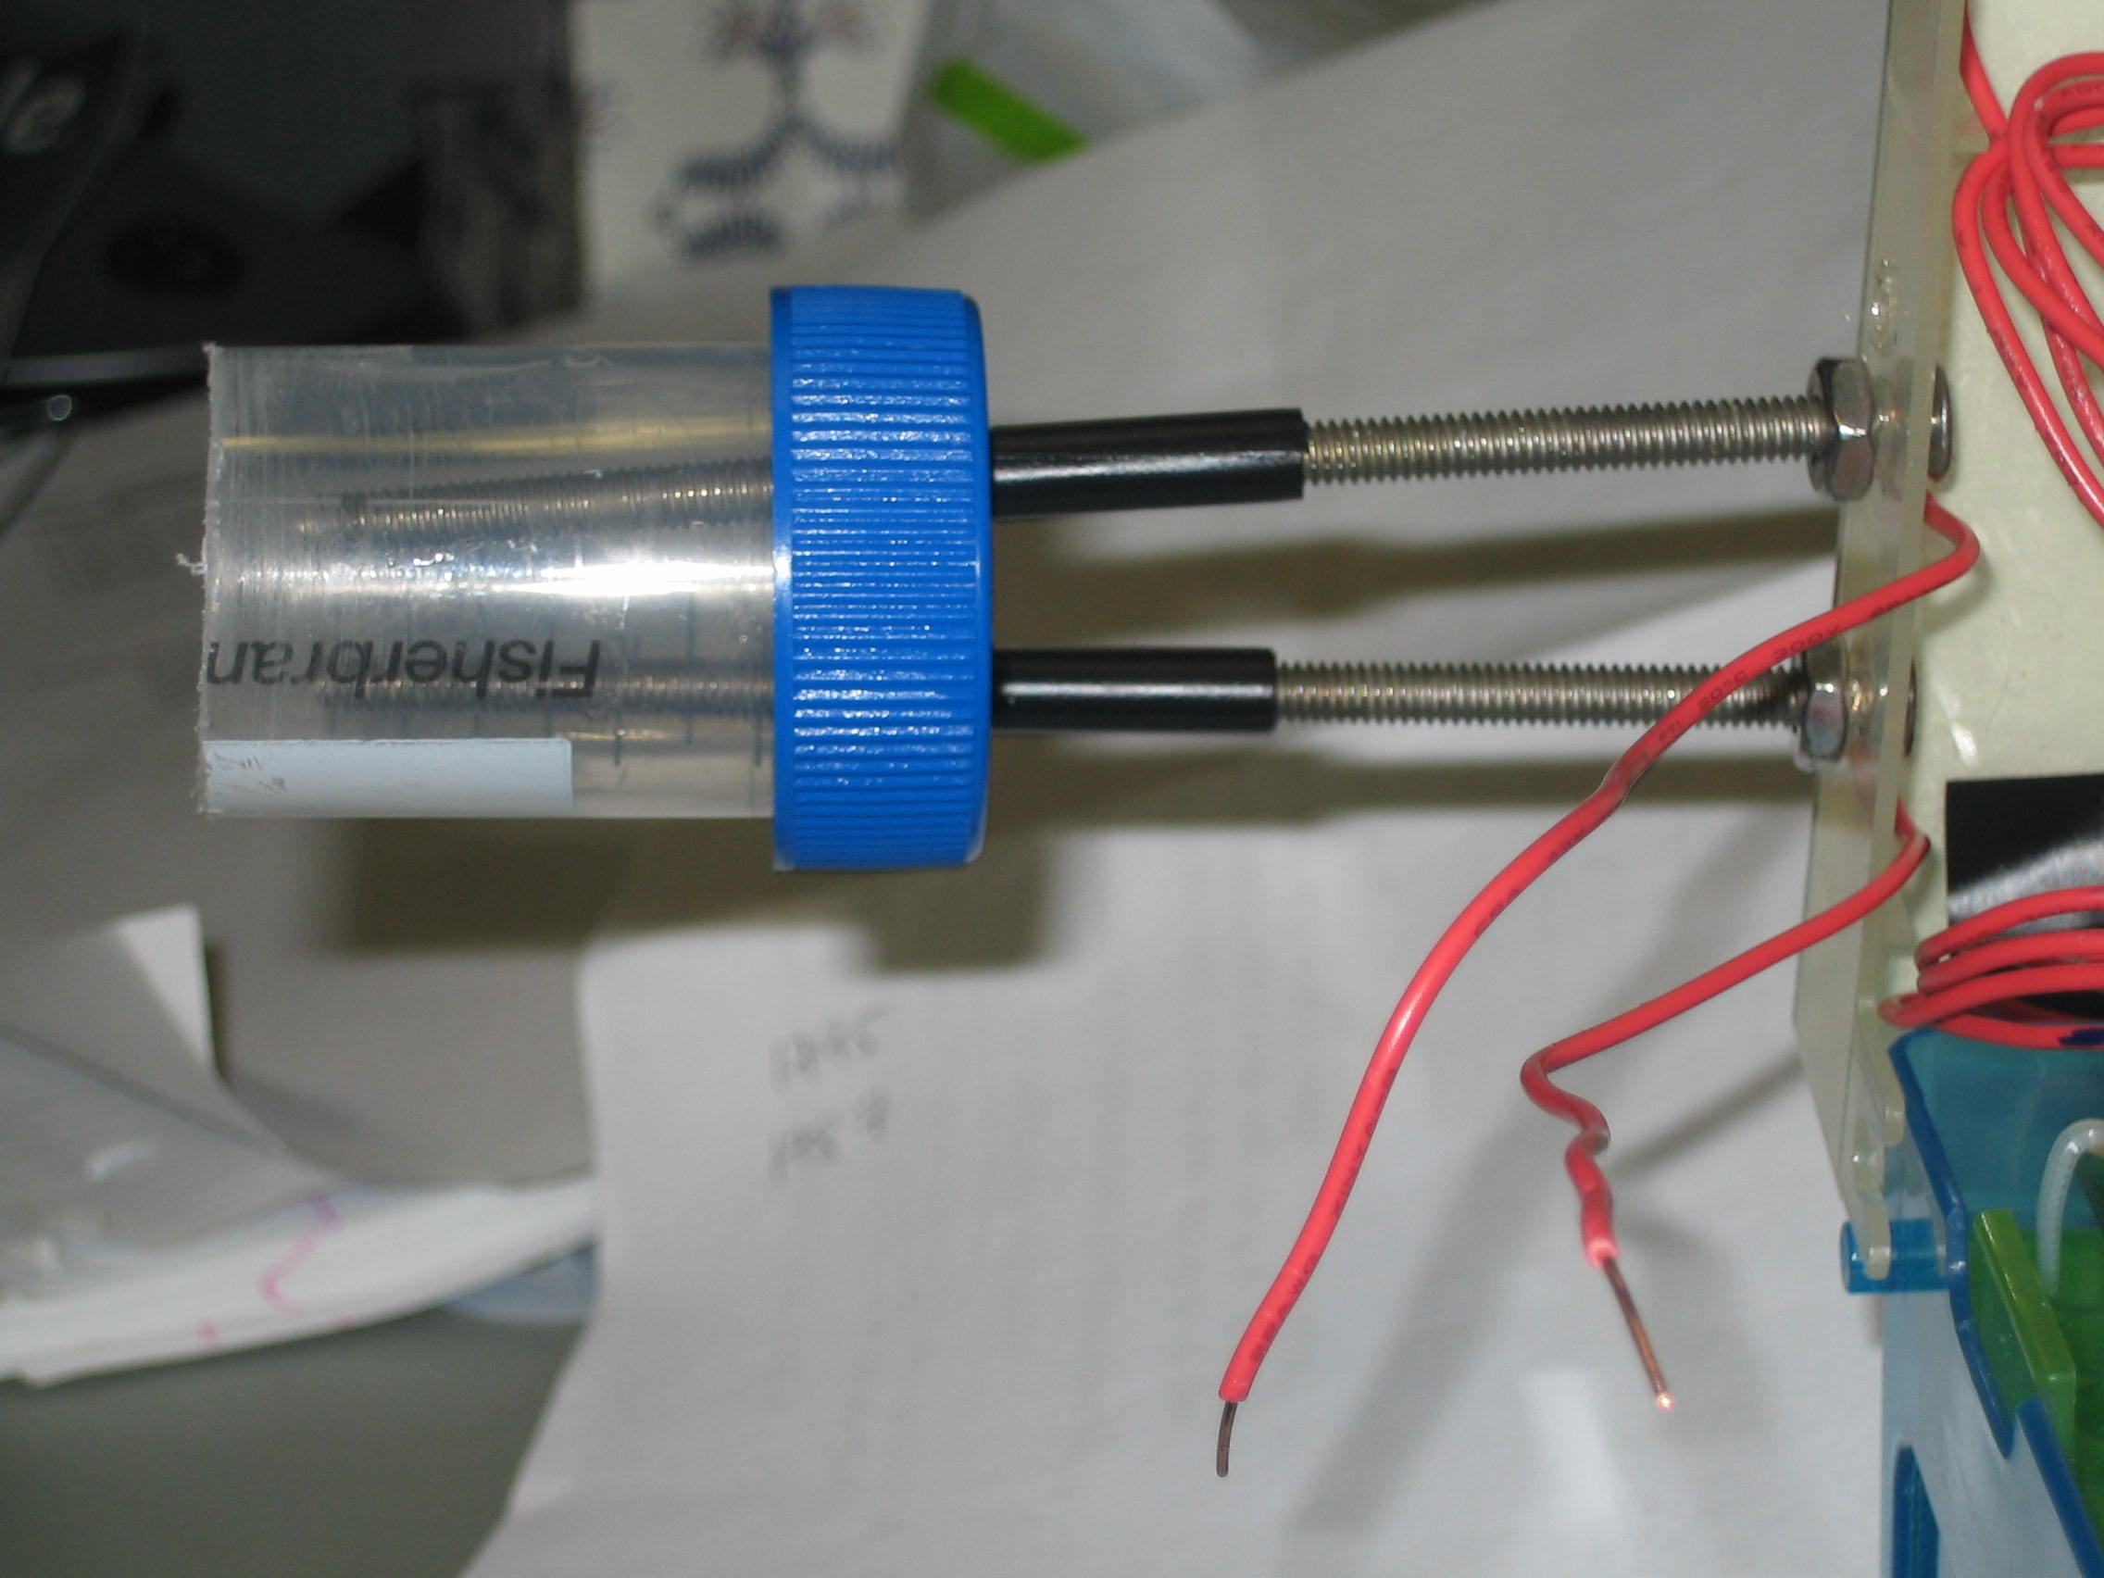
- Use a hack saw to remove the bottom half of the conical tube. Drill two holes in the cap (1 inch apart) and feed the two screws of the conductivity meter through. Have the conical tube slightly cover the ends of the screws. Lock the conical tube in place using nuts or electrical tape. The conical tube serves as a shield to minimize the effects of the electric field interacting with the container walls. The shield helps to ensures reproducible conductivity readings, regardless of the container used for measurement (see Figure 4).
Figure 4. Attachment of conductivity probes and conical tube.

- Download the conductivity meter program onto the BASIC Stamp module.
- Close the lid of the pipette tip rack and take conductivity readings (see Figure 5). Tip: Make sure the immersion depth of the conductivity probe is the same during the calibration and testing.
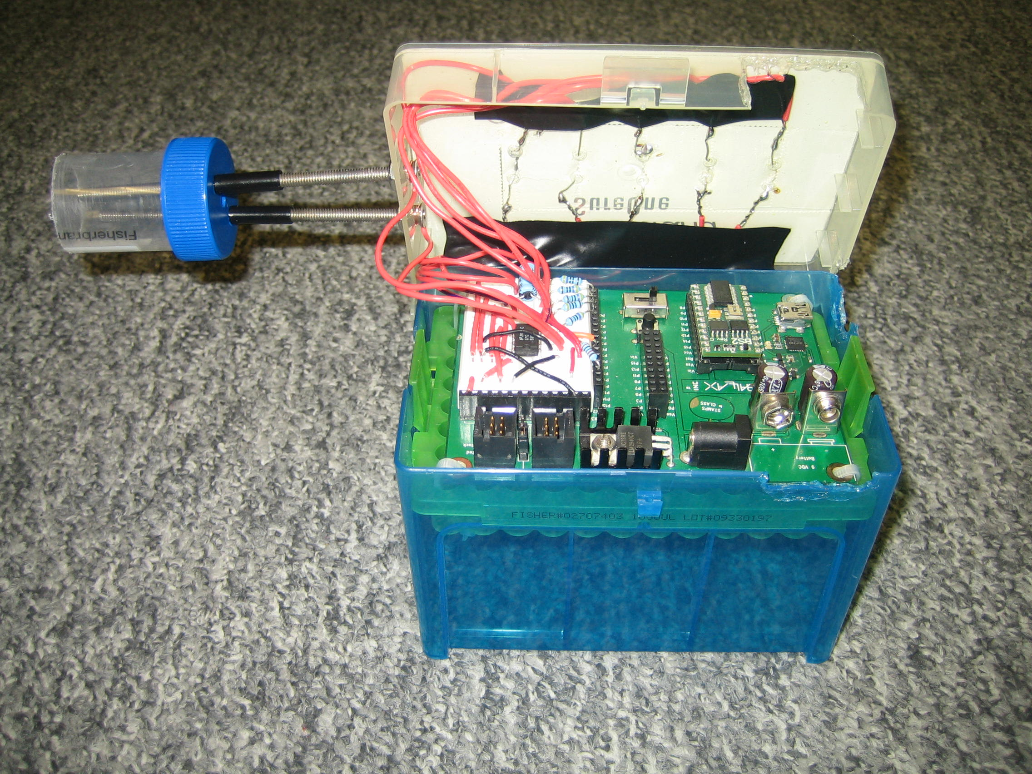
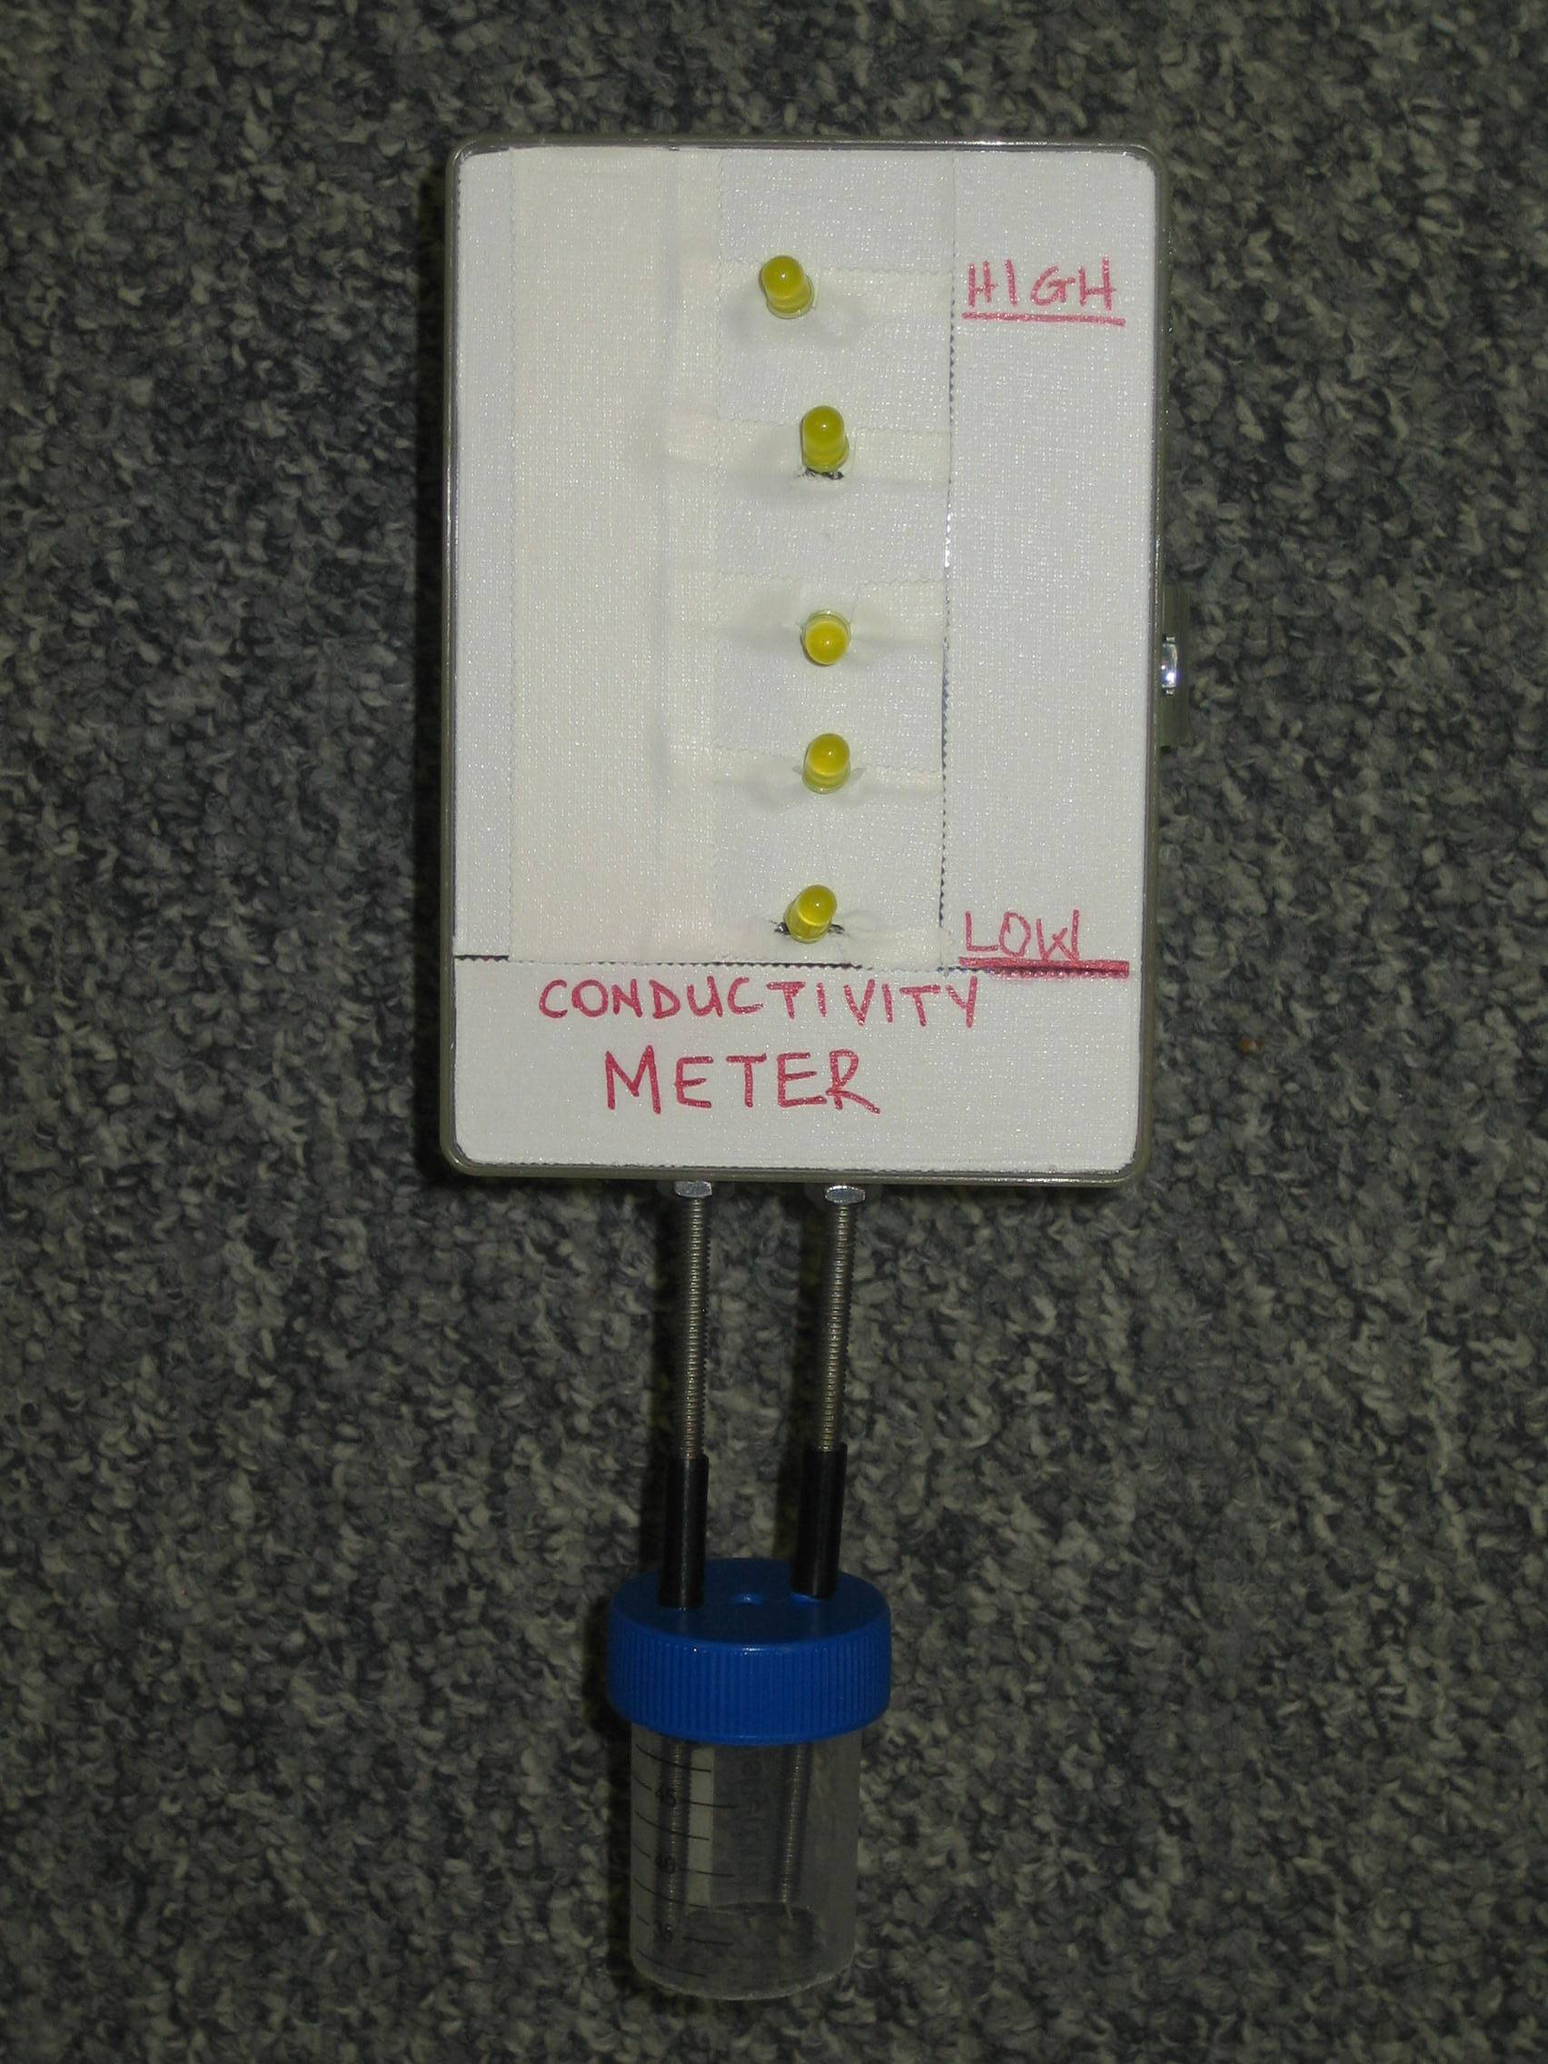

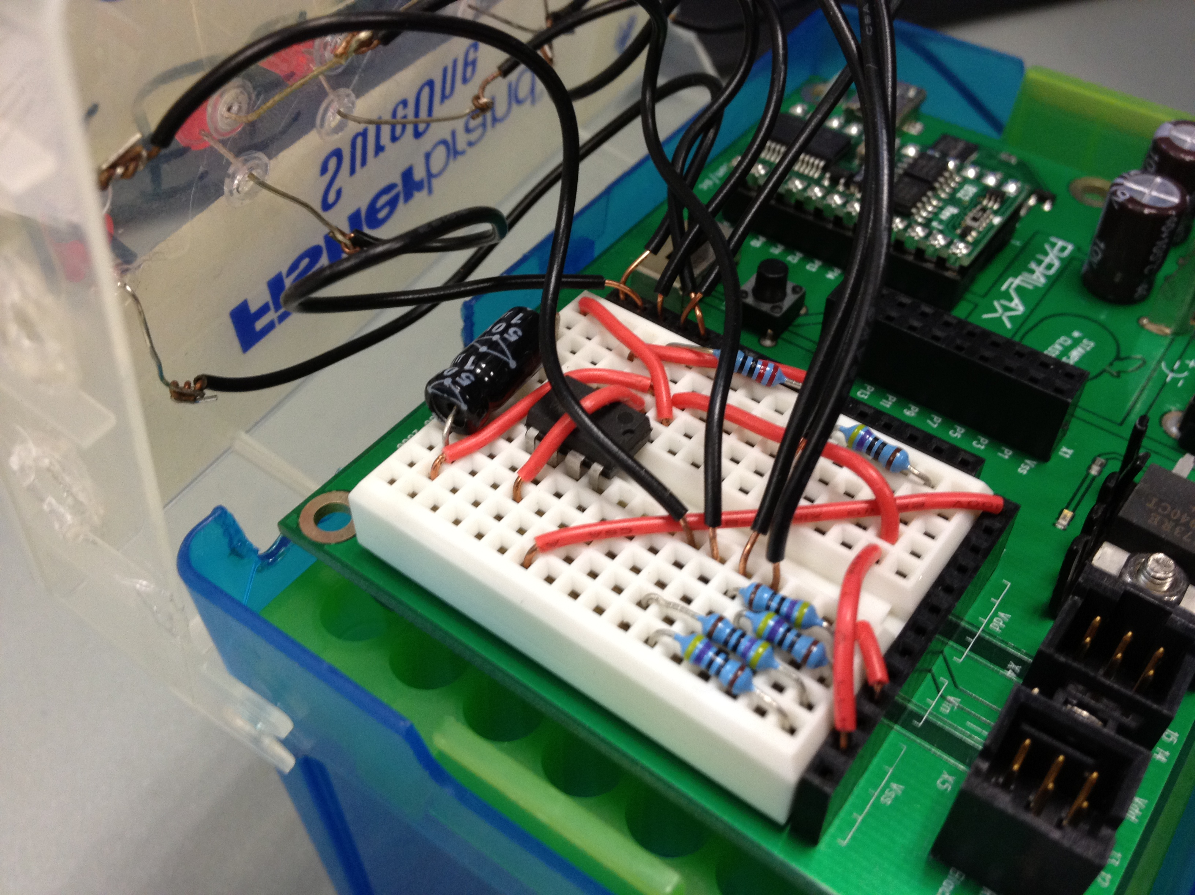

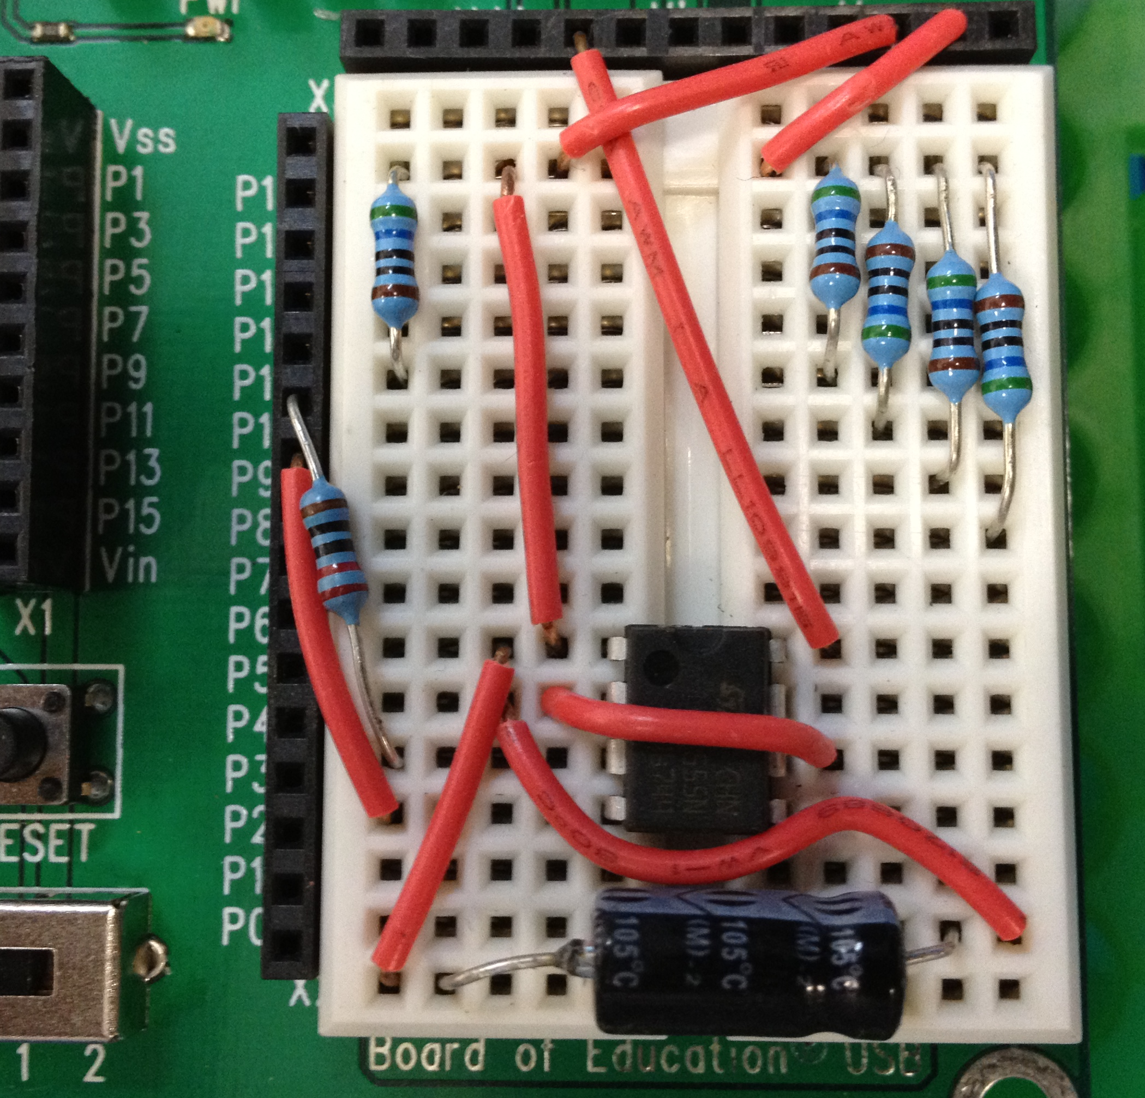
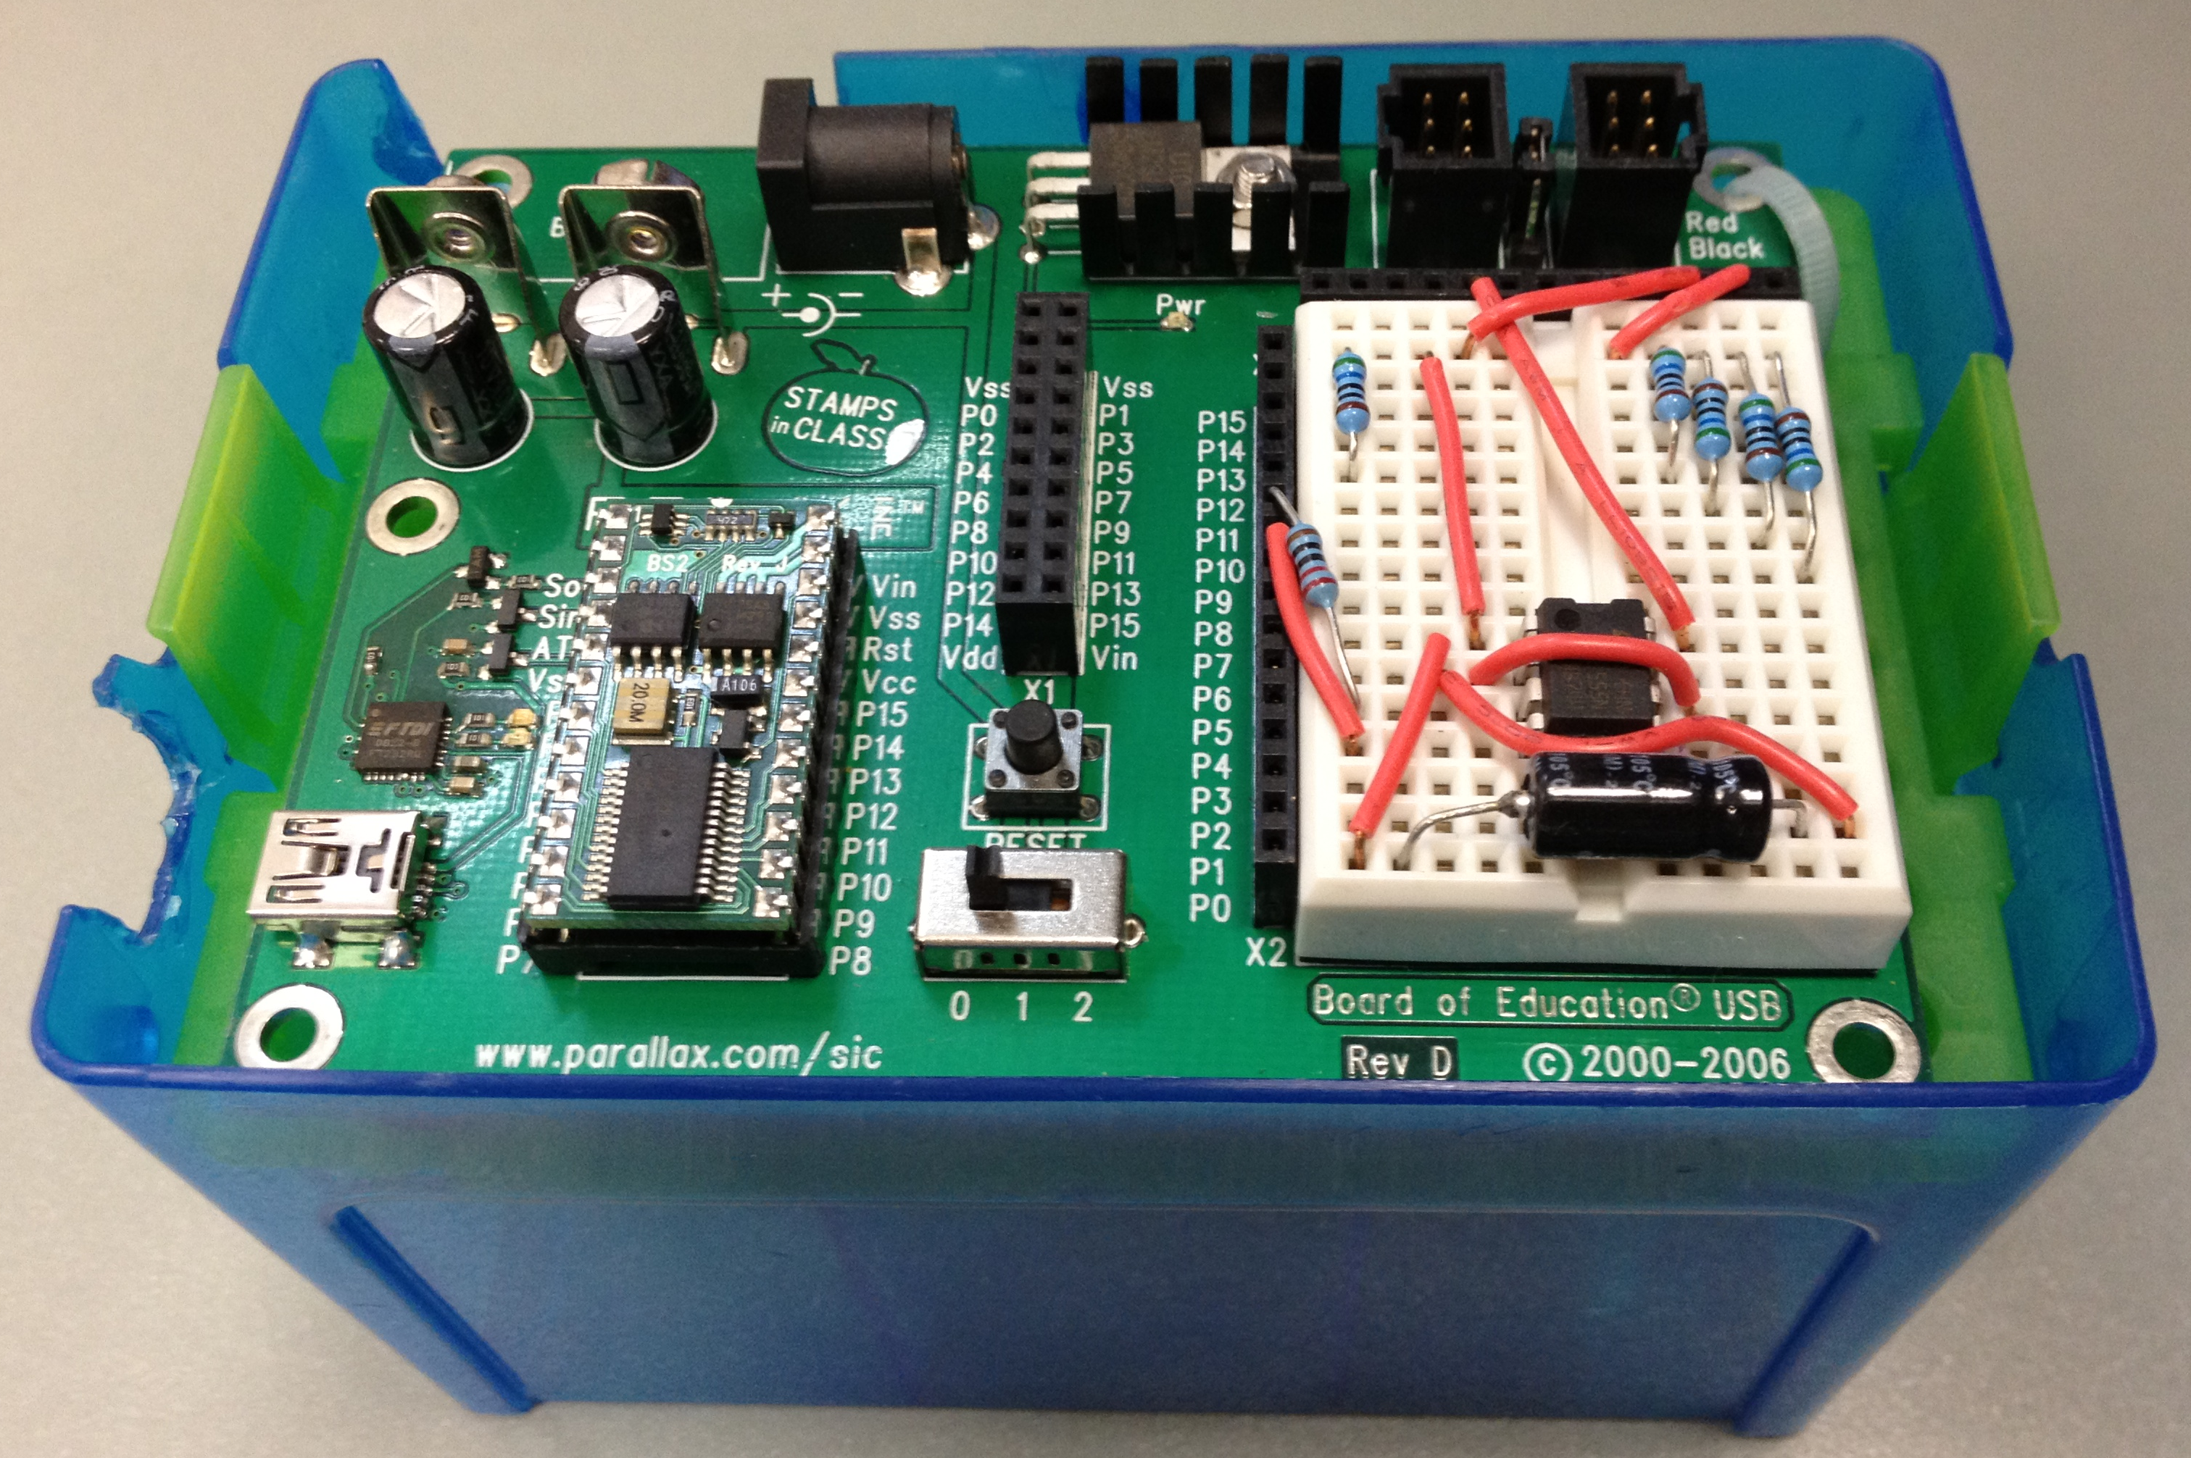

Figure 1. Completed Basic Stamp conductivity meter.

NOTE: Modifications to these instructions may result in improper meter functioning. It is strongly recommended that you perform your own meter calibration and verify output readings from the 555 timer for the various salt solution concentrations.

Calibration Instructions
Before use, calibrate the meter with regard to the range of salt solutions being used for the activity. That is, when the meter is immersed in a “low” concentration of salt, only one LED should be illuminated. Conversely, when placed in a “high” concentration of salt, all five LEDs should light up. As “low” and “high” concentrations are relative terms that are dependent on how the meter is used, they must be defined in the Conductivity of Gatorade Meter Program, so that the meter functions adequately.
- Open the Basic Stamp editor software and load the Conductivity of Gatorade Meter Program.
- Connect the conductivity meter to the computer using a USB cable. Run the program. (Make sure that nothing is touching the conductivity probes.)
- According to the program, “cnt = 0” should be displayed in the debug screen, and all the LEDs should blink with a 0.1s delay.
- Place the conductivity probes in your “low” salt concentration solution and record the value of “cnt.” For this activity, use a 0.01 M of NaCl as the low concentration.
- Wash the conductivity probe with water (all LEDs should blink when correctly cleaned, as in step 3).
- Place the conductivity probes in your “medium” salt concentration solution and record the value of “cnt.” For this activity, use a 0.03 M of NaCl as the medium concentration.
- Wash the conductivity probe with water (all LEDs should blink when correctly cleaned, as in step 3).
- Place the conductivity probes in your “high” salt concentration solution and record the value of “cnt.” For this activity, use a 0.05 M of NaCl as the high concentration.
- Using the values of “cnt” recorded for the low and high salt concentrations, determine the ranges of “cnt” values that the meter should use to illuminate the appropriate number of LEDs.
For example, suppose values of 900, 2700 and 4500 were obtained for the low, medium and high concentrations, respectively, then the program would be modified as follows, starting from line 16:
ELSEIF (cnt <=850 ) THEN
Light=%00000000
ELSEIF (cnt>851 AND cnt<= 1750) THEN
Light = %00000001
ELSEIF (cnt>1751 AND cnt<= 2550) THEN
Light = %00000011
ELSEIF (cnt>2551 AND cnt<= 3450) THEN
Light = %00000111
ELSEIF (cnt>3451 AND cnt<= 4350) THEN
Light = %00001111
ELSEIF (cnt>4351) THEN
Light = %00011111
Tip: If the difference between the high and low “cnt” values is small, changing the size of the capacitor used constructing the meter may help.

