Maker Racer Kit Contents List

Component: | Single Quantity:
Dowels | 3
Perpendicular Blocks | 2
1" Screws | 2
Hex Nuts | 2
Motor Mount(s) | 1
1.5-3V Motor(s) | 1
Connector Strips | 3
3in Slide Stop | 1
Zip Ties | 4
Wooden Wheels | 3
Battery Holder(s) (2 AA)  w/ Switch & Leads | 1
Mini Motor Hub Cover(s) | 1
Mini Motor Hub Base(s) | 1
Hub Screw(s) | 1
Toothpicks | 10
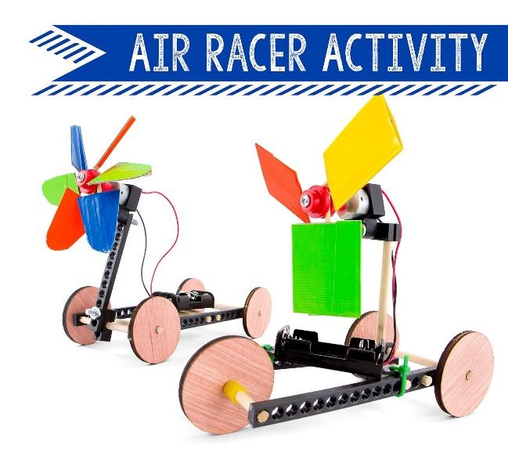
1 roll Duct Tape
1 roll Electrical Tape
1 pair Scissors
2 pair Safety Glasses
1 Multi-Cutter
1 Screwdriver
1 Pair of Pliers
1 Hammer
1 Slider Block
1 Reamer
1 Electric Air Racer kit
1 roll Duct Tape
1 roll Electrical Tape
1 pair Scissors
2 pair Safety Glasses
1 Multi-Cutter
1 Screwdriver
1 Pair of Pliers
1 Hammer
1 Slider Block
1 Reamer
1 Electric Air Racer kit
1 roll Duct Tape
1 roll Electrical Tape
1 pair Scissors
2 pair Safety Glasses
1 Multi-Cutter
1 Screwdriver
1 Pair of Pliers
1 Hammer
1 Slider Block
1 Reamer
1 Electric Air Racer kit

