Lesson Summary Assessment Answer Key

- The Perceptron model uses _________ to compare against a threshold value.
  - A weighted sum
  - A weighted average
  - The median
  - The mode

- If the value of input $x_{1}$is more important than the input of$x_{2}$ ,its weight will be __________ greater________ compared to the weight of $x_{2}.$

- Linear Separable means:
  - A set of points can be modeled using a linear function.
  - A line cannot separate two sets of points
  - Two sets of points can be separated by a single line
  - It takes two separate lines to separate groups of points

- In this picture below, the threshold value is = __1___.

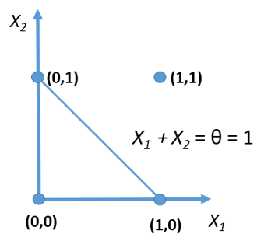

- Is the function illustrated in the picture above linear separable? Yes

- In the Perceptron model, what controls the amount of adjustment made between trials?

a. The bias
b. The learning rate
c. The error
d. The weights

