Notetaking Sheet
Free Body Diagrams
By definition, a free-body diagram is a representation of an object with all the forces that act on it. The external environment, as well as the forces that the object exerts on other objects, are omitted in a free-body diagram. This allow us to analyze an object in isolation. A free-body diagram (FBD) can be constructed in three simple steps: first, sketch what is happening on the body; second, identify the forces that act on the object; and third, represent the object as a point, the forces as arrows pointing in their acting direction, with origin at the point representing the object, with a size proportional to their magnitude and a label indicating the force type.
Practice. A solid with weight equal 10 N is suspended from the ceiling with two ropes, as shown in the diagram. Use a Free Body Diagram to determine the value the tensions on the two ropes
x
y
60º
40º

10 N

x
y
x
y

Bridge. Structure that is built over a railroad, river, or road so that people or vehicles cross from one side to the other.
Truss. A regular structure or frame built with straight members with end point connections and forces that act only at these end points. No member is continuous through a joint.
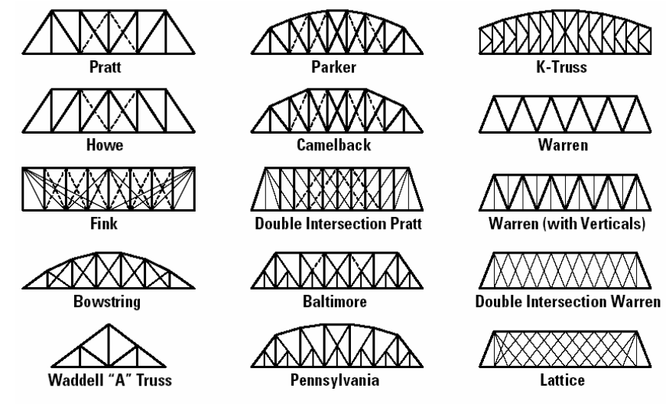
Truss Bridge. The bridge whose load-bearing superstructure is composed of a truss, a structure of connected elements usually forming triangular units. The connected elements (typically straight) may be stressed from tension, compression, or sometimes both in response to dynamic loads. The basic types of truss bridges ⁽¹¹⁾ are shown below:
Fig. 01. Common types of Truss Bridges ⁽¹¹⁾

Warren Truss. Design distinguished by equal-sized members and the ability of some of the diagonals to act in both tension and compression. The type is generally characterized by thick, prominent, diagonal members, although verticals could be added for increased stiffness.
Warren truss
Warren truss w/verticals

Pratt and Howe Trusses. These trusses are very similar, their trusses’ elements are arranged in right triangles. They differ in the orientation of the hypotenuse of these triangles (Fig. 16). The analysis of forces on these trusses is very similar.
Howe
Pratt

Warren Truss Analysis. The Method of Joints
In this section will be solved the simplest truss bridge: the Warren. The bridge structure in this example will be also the smallest possible, only three triangular elements, equilateral triangles of 4 in sides, and five nodes (Fig.07). The procedure here detailed can be extended to larger trusses.
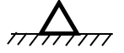
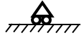
60º
4 in
2
1
3
4
5

Fig. 07. Warren truss bridge. Three equilateral triangles elements

In this analysis it is considered that (Fig.08):
(a). Vertical and equal downward forces of 10 lbf are applied on the top nodes 2, 4, and low 3: F₂, F₃, F₄
(b). The bridge is supported only by reaction forces at bottom nodes 1 and 5: R₁, R₅
(c). Only tension and compression forces are considered acting along the structure’s segments (Fig,08): F_{ij} (Force acting between node i and node j)
(d). Truss Elements are considered rigid. Structure’s segments do not bend.
(e). Once determined a tension or compression force at one end of the segment, the complementary force at the other end will be equal but in opposite direction: F_{ij} = - F_{ji} or F₂₁ = - F₁₂, F₃₁ = - F₁₃, F₃₂ = - F₂₃, etc.

5
F₂₄
F₄₂
F₂₃
F₂₁
F₄₃
F₄₅
F₂
F₄
R₁
F₁₂
F₃₄
F₃₂
2
4
R₅
F₅₄
3
1
F₃
F₃₁
F₁₃
F₃₅
F₅₃

Fig.08. Vertical downward forces on upper truss nodes and bottom mid node. Reaction forces at end bottom nodes .

Practice: Write on the next diagram, the corresponding forces acting on each of the truss nodes, according with the assumptions (a)-(e)
R₁

2
1
3
4
5

Practice. Find the value of the Forces of Reaction on Nodes 1 and 5, using Momentum of Forces.
Assumption: Bridge does not move then the momentum of all the vertical forces has to be zero

Momentum at Node 1
4
3
2
5
1

Momentum at Node 2
4
5
3
1
2

Practice: Analysis of Forces on Nodes using Free Body Diagrams and the assumptions ∑F_{y} = 0 and ∑F_{x} = 0
x
y
Node 1.

1

x
y
Node 2.

2

x
y
Node 3.

3

Node 4
x
y

4

x
y
Node 5

5

Practice: Put together the above obtained equations as a System of Equations. Label equations from (1) to (10)
Nodes | 1 | ∑F_{y} = 0
 |  | ∑F_{x} = 0
 | 2 | ∑F_{y} = 0
 |  | ∑F_{x} = 0
 | 3 | ∑F_{y} = 0
 |  | ∑F_{x} = 0
 | 4 | ∑F_{y} = 0
 |  | ∑F_{x} = 0
 | 5 | ∑F_{y} = 0
 |  | ∑F_{x} = 0

Practice: Solve the System of Equations. Identify the obtained forces as Compression (-) or Tension (+)
- Solve equation (1) for F₁₂:

- Substitute the obtained value for F₁₂ in equation (2), and solve for F₁₃:

- In equation (3) substitute the value for F₁₂, and solve for F₂₃;

- In equation (4) substitute the values for F₁₂ and F₂₃, and solve for F₂₄:

- In equation (5) substitute the value for F₂₃ and solve for F₃₄:

- In equation (6) substitute the values for F₁₃, F₂₃ and F₃₄, and solve F₃₅:

- In equation (7) use the value for F₃₄ and solve for F₄₅:

Practice. Create the matrix for the above System of Equations
Node |  | F₁₂ | F₁₃ | F₂₃ | F₂₄ | F₃₄ | F₃₅ | F₄₅

1 | ∑F_{y} = 0
 | ∑F_{x} = 0
2 | ∑F_{y} = 0
 | ∑F_{x} = 0
3 | ∑F_{y} = 0
 | ∑F_{x} = 0
4 | ∑F_{y} = 0
 | ∑F_{x} = 0
5 | ∑F_{y} = 0
 | ∑F_{x} = 0

Graphing Interface to Calculate Tensions-Compressions on Truss Bridges
This section summarizes how to use a very friendly computation interface developed in Google Sheets. This Graphic Interface:
- Calculates the tensions-compressions on the straight elements in the Warren Truss, Warren with Vertical Truss, Pratt Truss, and Howe Truss.
- Estimates the maximum strength of the trusses considering kind of wood used and element’s thickness.
- Gives only the solution when the truss is supported on its bottom end nodes only, the truss diagonal elements are round, and the truss rails are square. For square diagonals enter a diameter value such that the resulting cross sections matches the cross section area of the square diagonal.
The link to these interfaces is:
https://sites.google.com/gpapps.galenaparkisd.com/mramirez-math/courses-highlights/bridges/trusses-calculations
In this web page there are four interfaces (Figure 14(a)) corresponding to the four different trusses. Truss size is defined here by the number of triangles in the truss. Next table summarizes truss types and sizes:
Truss Type | Size (No. of triangles)
Warren | 3, 5, 7, 9, 11 (equilateral-isosceles)
Warren w/ Verticals | 3, 5, 7, 9, 11 (equilateral-isosceles)
Pratt | 6, 10,14 (right triangles)
Howe | 6,10,14 (right triangles)

To activate an interface in PC’s, laptops, and tablets, click on the gray square at the right top of the window. Click on the window when using a cellphone.

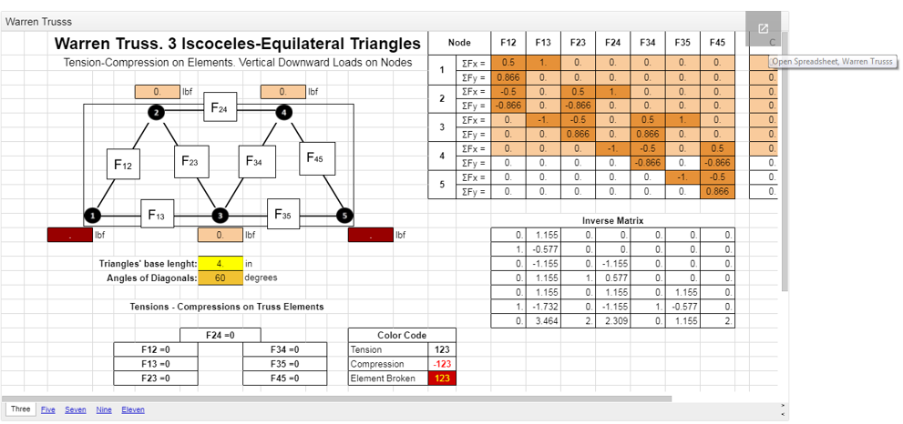

These interfaces are shared to everybody in the web, so any user opening these documents can input information. These worksheets are partially protected, such that only specific cells can be edited. This prevents a user accidentally or intentionally deletes important working formulas.
Once the spreadsheet is active, you can see its different sections
- A truss diagram with entries for the loads on each node.
- Two entries for the truss elements’ length and angle respect the horizontal.
- Cells to select the truss elements’ thickness and kind of wood they are made of.
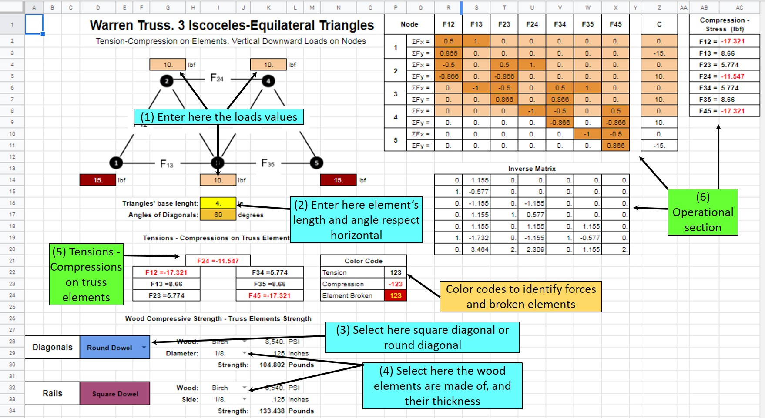

- Section displaying the calculated truss elements’ tensions-compressions
- The operational section: matrix associated to the system of linear equations obtained from the FBD’s, the inverse matrix, and the solutions of the system of equations.
You only have to input values in the cells in sections (1) and (2), and select the elements’ wood type and thickness in the cells in section (3). Sections (4) and (5), or other cells do not have to be altered. Tensions-Compressions on the truss elements are automatically calculated once values in sections (1), (2), or (3) are entered.
Important.
Because this files are open to everybody, everybody can modify your work and you can modify everybody’s work. So to keep your work’s integrity you will have to save a copy in your Google Drive of the interface you have to use.
Use the commands Share & export + Make a copy, give a new name to the file and save it in your Drive. You will work now in your saved file.
WARNING. Even though the original file cells that do not have to be modified are protected, the copies you saved possibly will not be protected. BE VERY CAREFUL and do not modify or erase other cells but the indicated in the practices.

Practice. Use the Google Slides Graphic Interfaces to solve four of the next problems. Your teacher may assign some specific to you.
1. Find the minimum Diagonals and Rails thicknesses for a Hardwood Warren Truss 20in long, made up with nine equilateral triangles, able to resist a load of 50 lfb on every top node and 100 lbf on every bottom node
2. Find the minimum Diagonals and Rails thicknesses for a Hardwood Pratt Truss 20in long, made up with six 30-60-90 right triangles, able to resist a load of 50 lfb on every top and bottom node.
3. Find the minimum Diagonals and Rails thicknesses for a White Pine Warren Truss 24in long, made up with seven equilateral triangles, able to resist a load of 60 lfb on every top and bottom node.
4. Find the minimum Diagonals and Rails thicknesses for a Basswood Pratt Truss 20in long, made up with six 30-60-90 right triangles, able to resist a load of 50 lfb on every top and bottom node.
5. Find the minimum Diagonals and Rails thicknesses for a Hardwood Warren Truss w/verticals, 20in long, made up with five equilateral triangles, able to resist a load of 70 lfb on every top and 80 lbf on every bottom node.
6. Find the minimum Diagonals and Rails thicknesses for a Hardwood Pratt Truss 20in long, made up with ten 30-60-90 right triangles that be able to resist a load of 60 lfb on every top node and 80 lbf on every bottom node
7. Find the proper wood to build a Howe Truss 36in long, made up with fourteen 30-60-90 right triangles, 3/8in Diagonals, 3/8in Rails, and able to resist a load of 40 lfb on every top and bottom node.
8. Find the proper wood to build a Pratt Truss 32in long, made up with fourteen 30-60-90 right triangles, 1/4in Diagonals, 5/16in Rails, and able to resist a load of 60 lfb on every top node and bottom node.
9. Find the proper wood to build a Warren Truss 36in long, made up with 11 equilateral triangles, 5/16in Diagonals, 1/2in Rails, and able to resist a load of 80 lfb on every top node and bottom node.
10. Find the proper wood to build a Howe Truss 30in long, made up with ten 30-60-90 right triangles, 5/16in Diagonals, 5/16in Rails, and able to resist a load of 50 lfb on every top node and bottom node.
11. Find the proper wood to build a Warren Truss 30in long, made up with nine equilateral triangles, 1/4in Diagonals, 5/16in Rails, and able to resist a load of 50 lfb on every top node and bottom node.
12. Find the proper wood to build a Pratt Truss 30in long, made up with fourteen 30-60-90 right triangles, 5/16in Diagonals, 1/2in Rails, and able to resist a load of 60 lfb on every top node and 80 lbf on every bottom node.

13. Find the maximum load equally distributed on every top node and on every bottom node a Poplar Howe Truss 30in long, made up with ten 30-60-90 right triangles, is able to resist, having 1/4in diagonals and 3/8in rails .
14. Find the maximum load equally distributed on every top node and on every bottom node a White Pine Howe Truss 36in long, made up with fourteen 30-60-90 right triangles, is able to resist, having 5/16in diagonals and 5/16in rails .
15. Find the maximum load equally distributed on every top node and on every bottom node a Poplar Pratt Truss 36in long, made up with ten 30-60-90 right triangles, is able to resist, having 1/8in diagonals and 3/8in rails .
16. Find the maximum load equally distributed on every top node and on every bottom node a White Pine Pratt Truss 34in long, made up with fourteen 30-60-90 right triangles, is able to resist, having 3/8in diagonals and 5/16in rails .
17. Find the maximum load equally distributed on every top node and on every bottom node a Poplar Warren Truss 30in long, made up with eleven equilateral triangles, is able to resist, having 3/8in diagonals and 3/8in rails .
18. Find the maximum load equally distributed on every top node and on every bottom node a Hardwood Warren Truss w/Verticals 36in long, made up with nine equilateral triangles, is able to resist, having 1/4 in diagonals and 3/8 in rails .

Note: Use the format at the back of this page to write your answers.

Problem ________
Truss | # Triangles in Truss | Span (in) | Diagonals/ Verticals Shape | Diagonal/ Verticals Thickness (in) | Rails Thickness (in) | Wood | Total/ Maximum Load (lbf)

Problem ________
Truss | # Triangles in Truss | Span (in) | Diagonals/ Verticals Shape | Diagonal/ Verticals Thickness (in) | Rails Thickness (in) | Wood | Total/ Maximum Load (lbf)

Problem ________
Truss | # Triangles in Truss | Span (in) | Diagonals/ Verticals Shape | Diagonal/ Verticals Thickness (in) | Rails Thickness (in) | Wood | Total/ Maximum Load (lbf)

Problem ________
Truss | # Triangles in Truss | Span (in) | Diagonals/ Verticals Shape | Diagonal/ Verticals Thickness (in) | Rails Thickness (in) | Wood | Total/ Maximum Load (lbf)

