Robots on Ice Student Worksheet
Part A: Probing Questions about Space
Before beginning the lesson, think about the following two questions. Jot down your ideas and get ready to share.
1. Do you think life exists in outer space? Explain.

2. Have scientists and engineers found life in outer space? What clues would we look for?

Part B: AEIOU Reflection
After slide 7, reflect on what you have just learned.
Then fill in a word or sentence that represents each letter, AEIOU.
A = Adjectives to describe the information.
E = Emotions you felt when seeing the information.
I = Something you thought was interesting.
O = Something that made you say, “Ohh!”
U = Something that made you say, “Uhh?”

A: ___________________________________________________________________________

E: ___________________________________________________________________________

I: ____________________________________________________________________________

O: ___________________________________________________________________________

U: ___________________________________________________________________________

Part C: Ready for Europa?
At lesson end, answer the questions below.
1. Compare the characteristics of Earth and Europa using a Venn diagram.
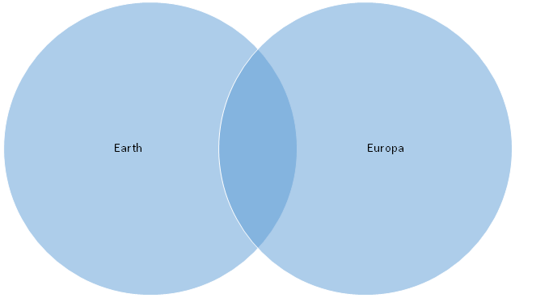

2. Do you think we will find life on Europa? Explain.

3. While Icefin is an innovative robot, it still needs a lot of work before it is ready for a mission to Europa. What design challenges will engineers need to tackle before launch?

