Acoustic Mirrors Analysis Worksheet Answer Key
Part 1: Recording Music with Audacity Software
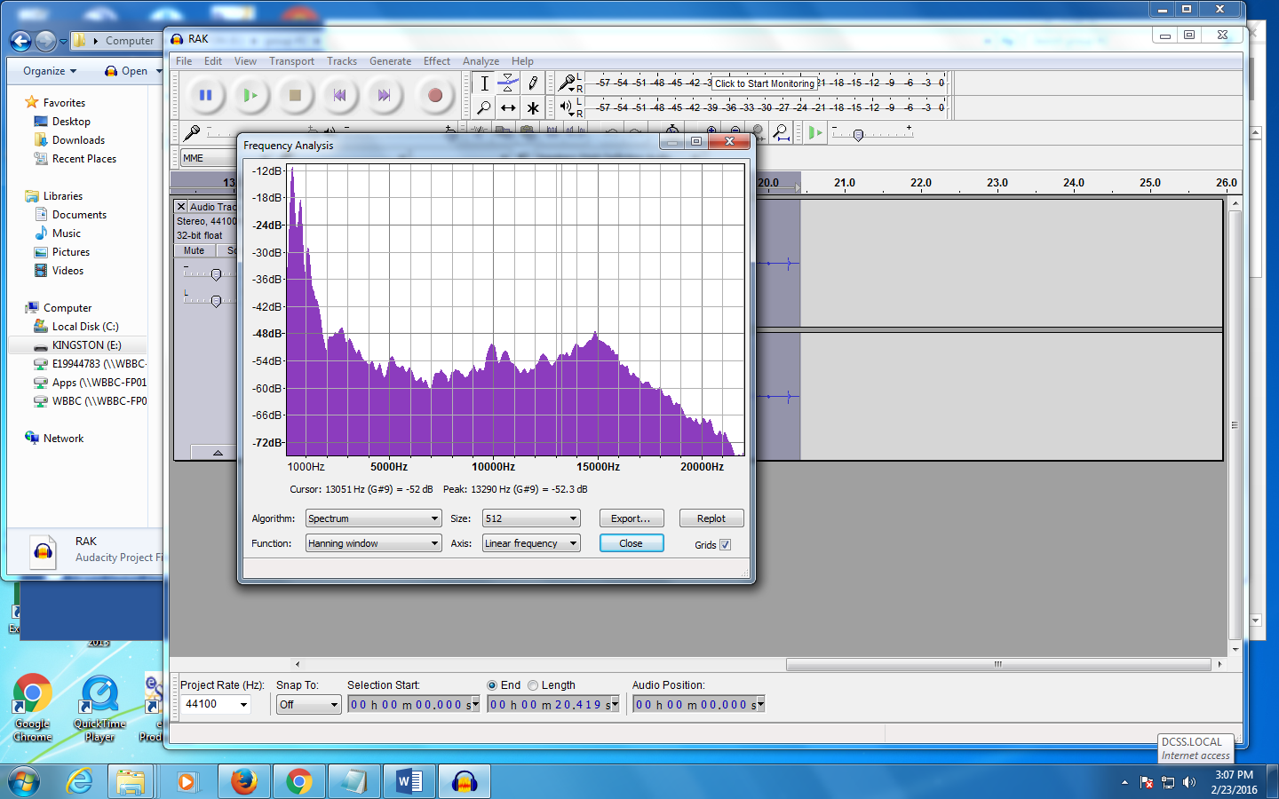
- Describe your plot spectrum below:

Example answer: The graph starts off at a high peak, then decreases, and gets lower towards the end.
- While the plot spectrum does not have labels, a graph should have them.
Based on the information displayed on the spectrum:
- What should the x-axis label be? Sound Intensity
- What should the y-axis label be? Frequency
- The plot spectrum displays a plot of “dB vs. frequency.” What is the graph showing?
The graph shows sound intensity in air as a function of frequency.
- On the plot spectrum, change the axis from linear to log. What is the effect?
When the axis on the plot spectrum is changed from linear to log, the range of the graph increases.

Part 2: Recording Music with Audacity Software and the Acoustic Mirror
- Draw a diagram of the experimental setup.

[Note that the above photograph does not show the microphone at the focal point.]
- Radius of curvature (C)
- What is the radius of curvature of your mirror? Example answer: C = 15 cm
- How did you determine the radius of curvature?
We measured the distance from the vertex to the center of curvature.
- Determine the focal length of your mirror. Show your calculations.
focal length = ½ radius of curvature
f= ½ C
f= (.5)*15
f = 7.5 cm
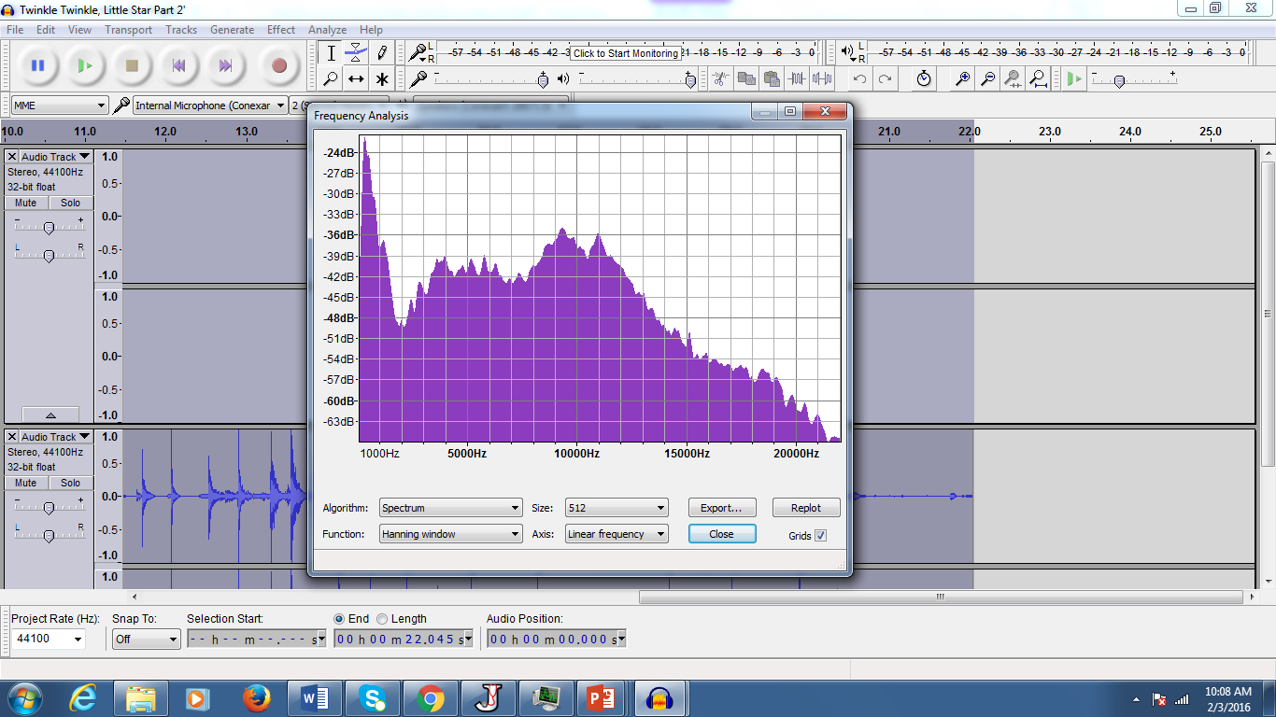
- Sketch the plot spectrum below:

- How does your plot spectrum compare to the graph in Part 1?
Using the acoustic mirror, the magnitude of sound intensity increased.
Part 3: Adding Effects with Audacity Software
- Describe the effects you added to a sound file that you saved during this investigation.
Example answers:
- Reduced all the background noise
- Increased the pitch and the frequency analysis
- Added the reverse and echo effects
- Amplified the song
- Added speed effect
- Changed the tempo

