Strum Along Worksheet

The energy of a sound wave increases with its amplitude.

Chose the bracketed span (1 or 2) that represents the amplitude of the sound wave:
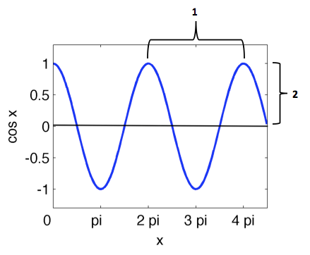 __________

Which of the sound waves below has the larger amplitude (A or B)? __________

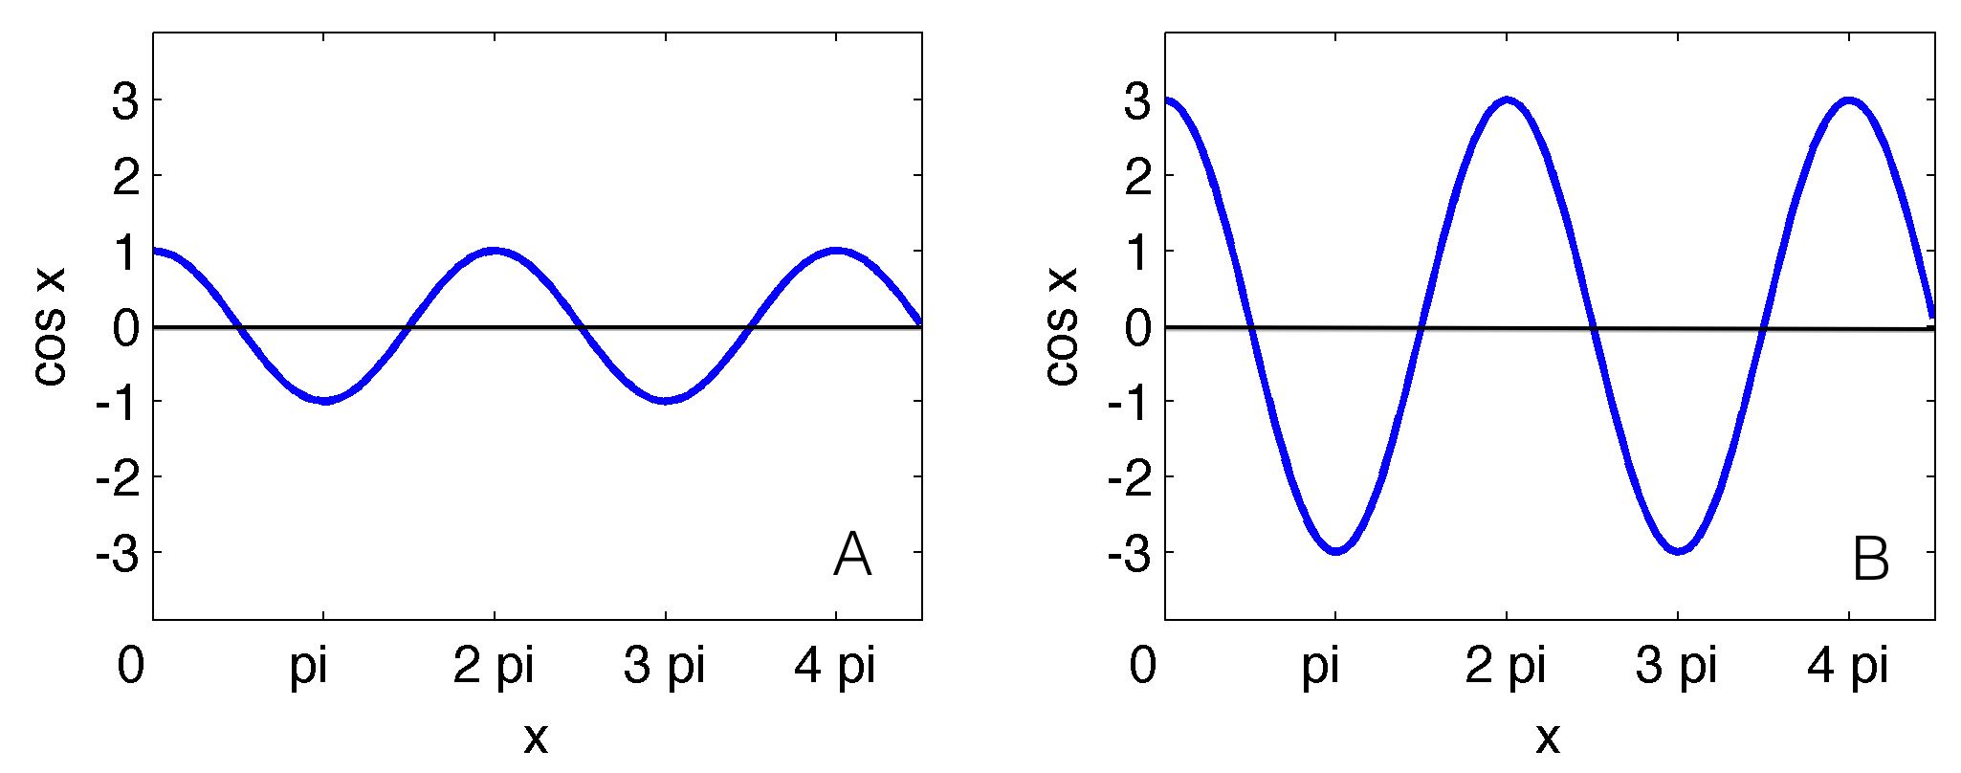

Which of the sound waves above has more energy (A or B)? __________

The volume of sound that you hear is related to the energy of the sound.

Do you expect the volume of the sound to increase or decrease __________
as the energy increases?

What can you do to increase the volume (or energy) of the sound waves produced by your guitar?

__________________________________________________________________________________________
A guitar string was plucked multiple times by applying different levels of force to the string. The energy and amplitude of each “pluck” was recorded in the chart below.

Plot the data from the chart on the graph.

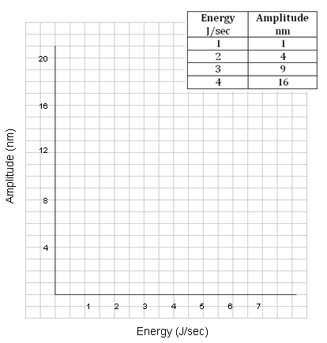

How can you represent the relationship between energy and amplitude with a mathematical statement? (Fill in the blank.)

Energy is proportional to the ____________ root of amplitude.

Using E for energy and A for amplitude, write your statement as a mathematical expression.

__________________________________________________________________________________________

