Ceramic Filtration

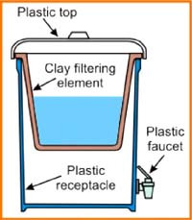
How Does It Work?
Porous ceramic materials can be used to physically filter microbes depending on the size of the pores in the ceramic. One example of a ceramic filter is the Filtrón. The Filtrón is made by firing ceramic pots with bits of sawdust in the clay that burn away and leave pore spaces. Candle filters can also be used. They are usually made of diatomaceous earth or porcelain with pore sizes of 0.3 to 50 microns (at ≤ 1.5 microns, all pathogens are removed). Disinfection can be increased for either of these ceramic filters by coating them with colloidal silver.
TeachEngineering.org – Free STEM Curriculum for K-12
In Practice
The Filtrón is placed in a 5-gallon plastic bucket with a lid and a tap. Similarly, candle filters are typically placed in a bucket in such a manner that water filters through the candle filters on the way to a second bucket below.
Ceramic filters are periodically cleaned by manually scrubbing and rinsing to remove particles. Candle filters are wiped clean and boiled and then checked for cracks and fissures. Filters coated in colloidal silver need to be recoated approximately once per year.
Time to Treat: 0.3-2 L/hour for common household filters, such as candle filters or the Filtrón
Cost: $8-$10 for filter unit; $4-$5 for replacement ceramic pot
Advantages | Disadvantages
Can be made from locally available materials | May have to purchase replacement filter
Production can create a marketable skill | Slow filtration rates
Can wash to clean | Will clog quickly if water is turbid
Simple to maintain | Fragile and can break easily

