Carbon Cycle Reference Sheet
Carbon is essential for life on Earth and is found in all living things!
Carbon is found in…
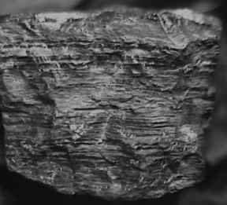 | 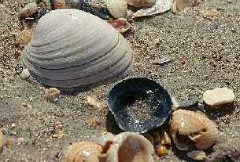 | 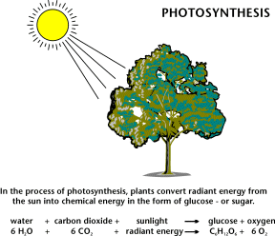 | 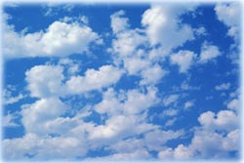
Coal | Seashells | Plants | Atmosphere

The carbon cycle can be described as the exchange of carbon between the land, the oceans, the atmosphere, and the earth’s interior. Nature does a very good job at balancing the carbon cycle by making sure that too much carbon does not accumulate in one place. Over the past 100 years, human activity has disrupted the carbon cycle by releasing too much carbon into the atmosphere. Many people believe that burning fossil fuels and adding extra carbon into the atmosphere is causing a problem known as “global warming.”
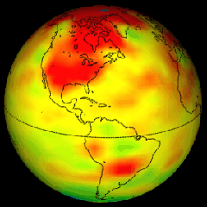
Global Warming5
Global warming is the increase in the average temperatures of the Earth’s atmosphere. Climate change can negatively affect human health, animal health and the environment by disturbing ecosystems, causing drought and changing crop growing seasons.
How can you help the Earth?
Engineers are working to rebalance the carbon cycle by decreasing the amount of CO2 that is released into the atmosphere. You can also make a big difference by conserving energy!
- Remember to turn off the lights, computers and stereos when not in use
- Take shorter showers
- Ride a bike or walk
- Talk to your family about recycling

Argonne National Laboratory http://chemistry.anl.gov/carbon/coal-tutorial/images/colchunk2bw.gif
U.S. National Park Service http://www.nps.gov/archive/calo/graphics/seashells.jpg
U.S. Energy Information Administration http://www.eia.doe.gov/kids/energyfacts/sources/renewable/images/photosynthesis1.gif
U.S. Geological Survey http://ga.water.usgs.gov/edu/pictures/wcclouds.jpg 5National Oceanic and Atmospheric Administration http://www.noaanews.noaa.gov/stories/images/globalwarming5.gif

