Isometric Drawing Worksheet Answer Key
Instructions
Draw the isometric view of each letter in the third column of the table. Make sure that the number of cubes you use to draw each letter matches the number used in the “Front view” of the letter.
Letter to Draw | Front View | Isometric View
A | 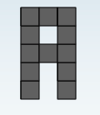 | 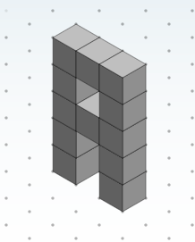
J | 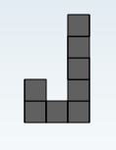 | 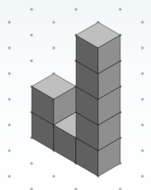
Z | 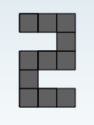 | 