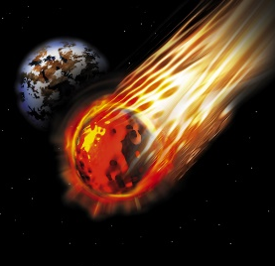
How Big is That Crater? Worksheet

Experiment 1: Crater Size
- Predict the size of the crater based on the size of your rock.

Rock | Crater diameter | Crater depth | Observations
Rock 1 (diameter = _______)
Drop1
Drop 2
Drop 3
Average
Rock 2 (diameter = _______)
Drop1
Drop 2
Drop 3
Average
Rock 3 (diameter = _______)
Drop1
Drop 2
Drop 3
Average
Rock 4 (diameter = _______)
Drop1
Drop 2
Drop 3
Average
- Observe the crater size made by meteoroids (your rock drops) of different sizes. Record your observations in the table below. Once you have recorded three trial drops for each of the 4 objects, average the results per rock.

- In the space below, make an x-y plot of the average crater diameter versus rock number.

- Based on the trends that you observed in your data and transferred to your plot, predict the effect on the size of crater should a meteor actually impact the Earth.

Experiment 2: Crater Size Related to Speed of Impact
- Predict the effect on the size of the crater should you increase the height from which you drop your object.

- Using a blank table (see next page), format the table to best record your data. (Hint: It should be similar to the table in Experiment 1). Show your teacher your formatted data table before you begin testing; s/he should sign off on your table. Teacher initials: ________

- Use your findings to make a prediction about what effect the velocity of a meteor would have on a crater it creates once it impacts Earth.

- Were your predictions correct? If not, why?

Designing an Earth Protector
- In the designated space below, draw a diagram of your Earth Protector, labeling the various components.

