Gravity-Fed Water Systems for Developing Communities Activity—Gravity Fed Water System Design Worksheet
Directions
Today you’re going to be designing a model gravity-fed water system. Systems, such as the one you are about to design, are used all over the world to bring clean drinking water to people in developing countries. Before you start designing, please answer the following conceptual questions as a group below.
Part 1: Conceptual (Day 1)
- Name the four system parameters that dictate water velocity and flow and must be considered when designing a gravity-fed water system.
  - __________________ (Hint: why does it matter that there are mountains nearby?)
  - __________________ (Hint: amount of people x amount of water used/person)
  - __________________ (Hint: has to do with the pipes themselves)
  - __________________ (Hint: has to do with the pipes themselves)
- What typical problems do you think could result by not correctly addressing each of the design parameters in question #1?
  - ________________________________________________________________________
  - ________________________________________________________________________
  - ________________________________________________________________________
  - ________________________________________________________________________
- What is sedimentation?
______________________________________________________________________________
______________________________________________________________________________
- What is turbidity?
______________________________________________________________________________
______________________________________________________________________________
Part 2: Design (Day 1 and 2)
Now that you have thoroughly brainstormed the necessary systems parameters to take into account, you are ready to start designing. The objective of this design is to have:
- The highest amount of flow between the 3 tubs (without overflowing), and
- To have the lowest turbidity.
Design Template
Below is an elevation view of your gravity-fed water system model without dimensions.
On this page, draw the tubes between the different tubs, indicate the height of each tub (1-3) with respect to the classroom floor, and indicate the tube sizes between each tub (1 and 2).

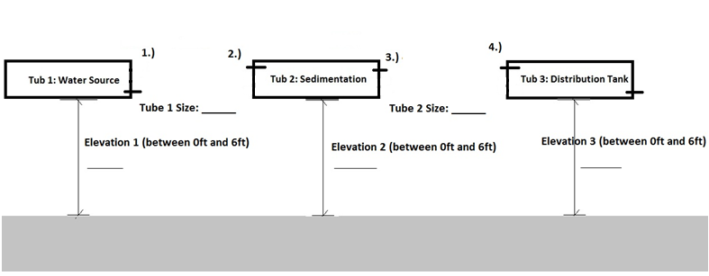

Part 3: Presentation of Rationale (Day 2)
Complete the following questions with the reasoning (rational) why your team chose the particular connection orientation, tub elevation, and tube size. Each group will present their rationale to the class.
Connections:

- Why do you think the orientation of connection 1 needs to be at the bottom of the tub?
______________________________________________________________________________
______________________________________________________________________________
- Why do you think the orientation of connection 2 needs to be at the top of the tub?
____________________________________________________________________________________________________________________________________________________________
- Why do you think the orientation of connection 3 needs to also be at the top of the tub (the same orientation as connection 2)?
_____________________________________________________________________________
_____________________________________________________________________________
- Why do you think the orientation of connection 4 needs to be at the top of the tub?
_____________________________________________________________________________
_____________________________________________________________________________
- Why do you think the orientation of the exit hole from the final tub needs to be at the bottom of the tub?
_____________________________________________________________________________
_____________________________________________________________________________
Tub Elevations:

- Why did you choose this elevation for tub 1?
______________________________________________________________________________
______________________________________________________________________________
- Why did you choose this elevation for tub 2?
____________________________________________________________________________________________________________________________________________________________
- Why did you choose this elevation for tub 3?
_____________________________________________________________________________
_____________________________________________________________________________
Tube Sizes:

- Why did you choose this size for tube 1?
______________________________________________________________________________
______________________________________________________________________________
- Why did you choose this size for tube 2?
____________________________________________________________________________________________________________________________________________________________
Part 4: Design Testing and Iteration (Day 3)
- After the system was running, were there any issues with tub overflowing (or under flowing: not enough flow with respect to the other tubs? Why do you think this happened?
____________________________________________________________________________________________________________________________________________________________

- What was the turbidity? What was the affect of sedimentation on the level of turbidity (NTU)?
____________________________________________________________________________________________________________________________________________________________
- How would you change about the following parameters to make the system work better? Why?
Flow
Elevation: _____________________________________________________________________
Tube Size: _____________________________________________________________________
Turbidity
Elevation: _____________________________________________________________________
Tube Size: _____________________________________________________________________
- Why do you think it is important to have the entry and exit of water into the sedimentation tub (Tub 2) at the top of the tub?
____________________________________________________________________________________________________________________________________________________________
Design Revision
You now have the opportunity to change your design (as many times as you want!). Do so until you obtain the best result for flow and turbidity!

- What worked best (circle one answer for each)?
Elevation:
ft. Why?
ft. Why?
ft. Why?
Tube Size:
in. Why?
in. Why?

