Example Hole Designs and Keys for Teacher
These are the same designs and keys as are available at the provided GeoGebra URLs.
Hole 1 http://ggbtu.be/mUKqXPMC8
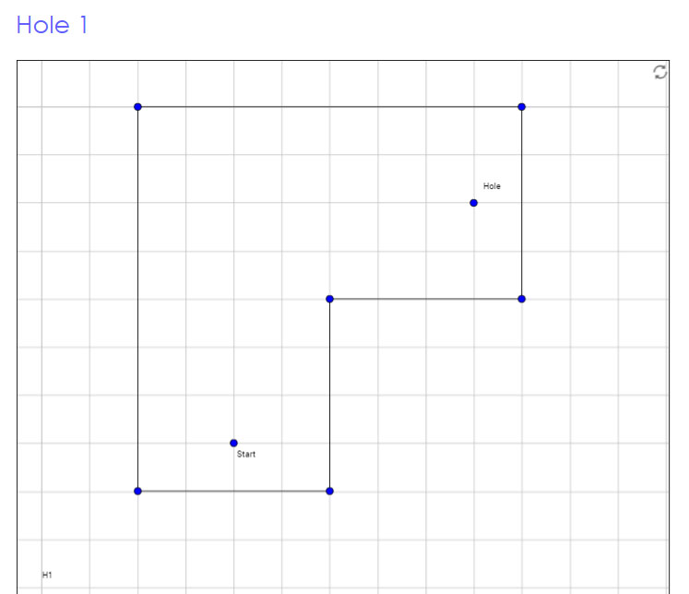

Hole 1 Key a http://ggbtu.be/mfw55z5z9
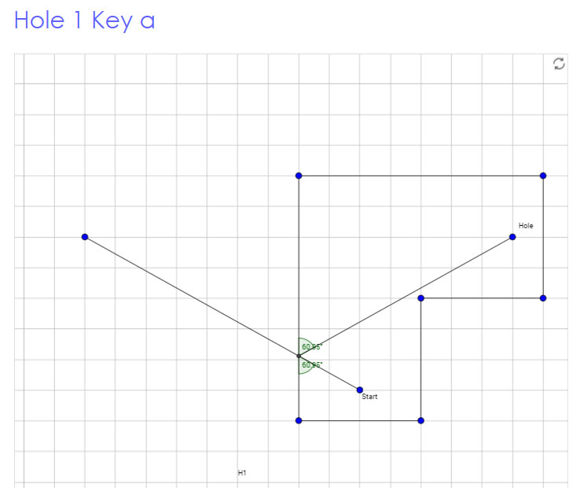
(1-bank solution)

Hole 1 Key b http://ggbtu.be/mvyZFKgHx
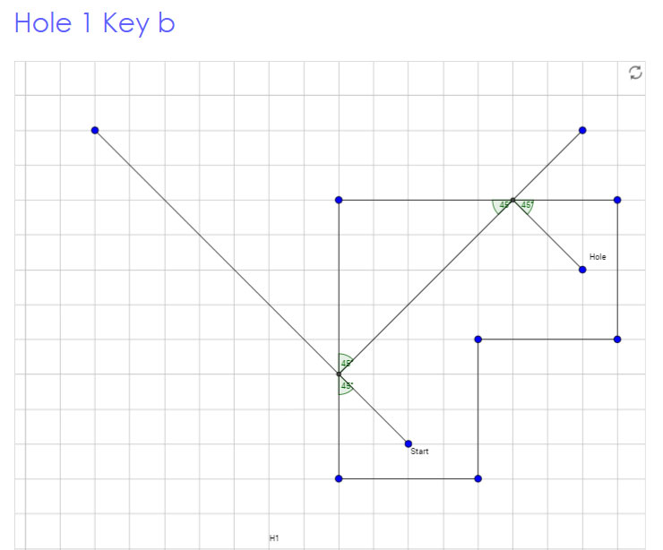
(2-bank solution)

Hole 1 Key c http://ggbtu.be/mybMtj5RM
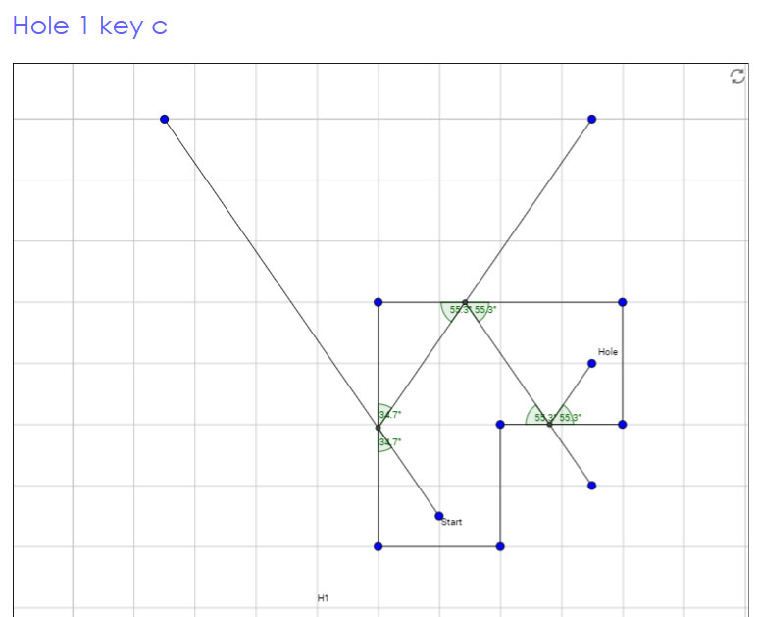
(3-bank solution)

Hole 2 http://ggbtu.be/m3049151

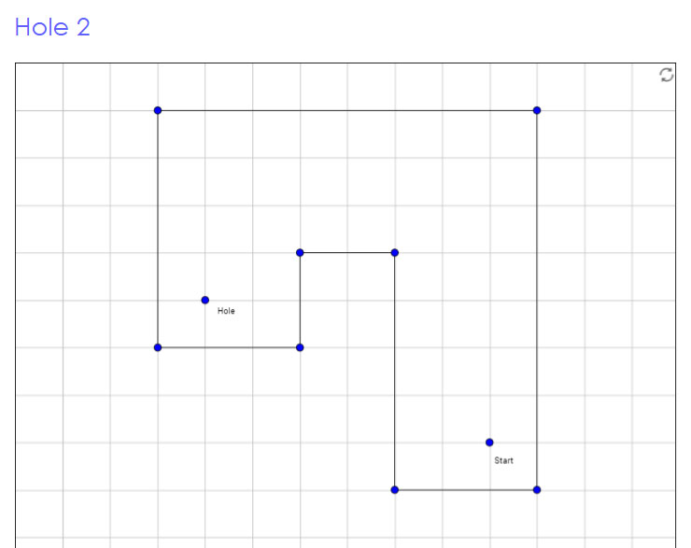

Hole 2 Key a https://www.geogebra.org/m/ndUn2Kxs
Hole 2 cannot be completed in a 1-bank shot since a 1-shot attempt would cut across the perimeter of the hole (as shown below), which is not possible; so, the hole requires 2 or more banked shots

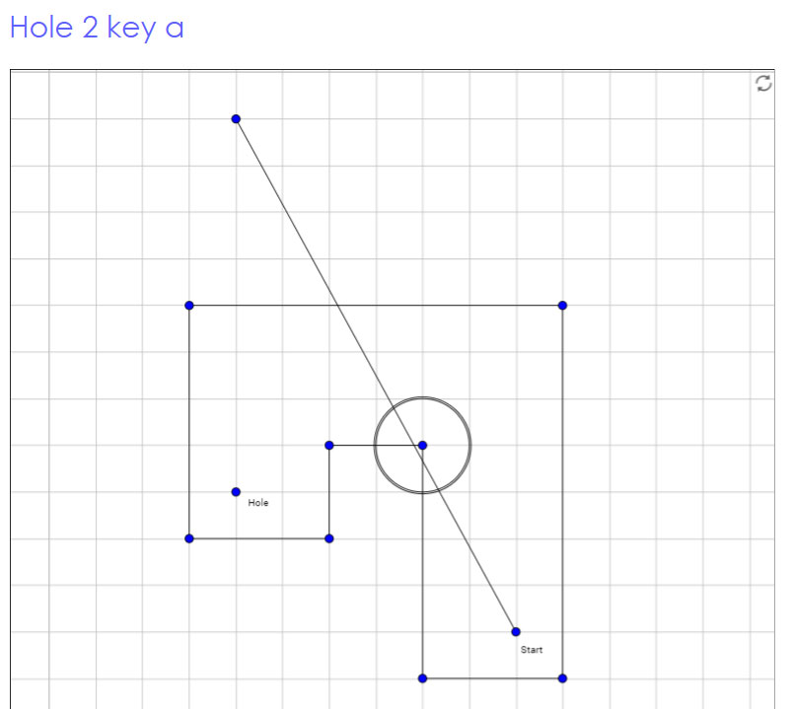

Hole 2 Key b https://www.geogebra.org/m/UTmMHa3e
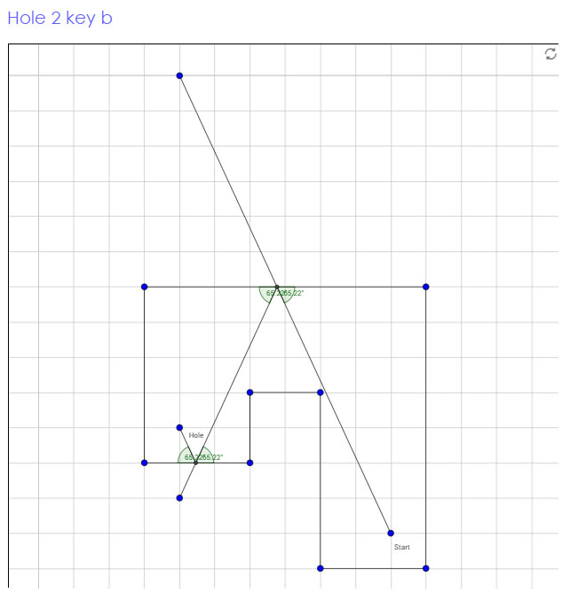
(2-bank solution)

Hole 2 Key c http://ggbtu.be/mThcYxmQC

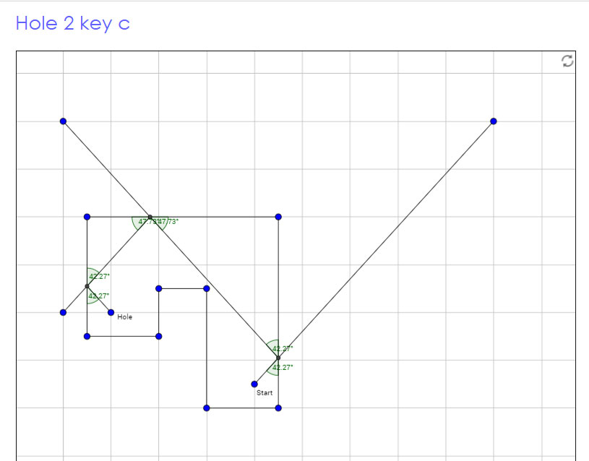
(3-bank solution)

