Seeing Sound Worksheet
Instructions: At each activity station, complete the questions below.
Station 1: Oobleck Dance
- Observe how oobleck responds to a range of low-frequency sounds. At which frequency does oobleck dance most wildly?

- Do sound waves need high or low amplitude in order for oobleck to dance? How can you tell?

Station 2: Sound Visualization
- Can you see that sound is a wave? How can you tell?

- Can you feel that sound is a wave? How can you tell?

- How do high- and low-frequency sounds change what the water (or grain) looks like?

- Do high-frequency sounds have long or short wavelengths?

Station 3: Testing homemade Speakers
- How does the yogurt cup speaker make sound? How do you hear this sound?

- Using the materials in the box, how were you able to amplify the sound from the yogurt cup speaker as much as possible? What did you discover?

Station 4: Practice Problems
- Label amplitude and wavelength on the drawing of Wave 1.
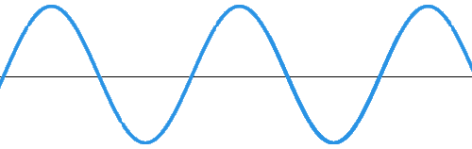

- In the box below, draw a wave with the same wavelength as Wave 1, but lower amplitude.

- In the box below, draw a wave with higher frequency than Wave 1, but the same amplitude.

- In the box below, draw a wave with lower frequency and amplitude than Wave 1.

Station 5: How Do Stringed Instruments Make Sound?
- Take a length of string and pull it just tight enough to hear a sound when the string is plucked by a teammate. Is this a high- or low-frequency sound? Does this sound have high or low pitch?

- Pull the string tighter. Does this sound wave have higher or lower frequency than before?
Is the pitch higher or lower than before?

- If you pluck the string more strongly so that the sound is louder, what happens to the sound wave?

- Pluck the string on top of a petri dish with water. Do you see evidence that the sound made by the string is a wave?

- Why do you think stringed instruments have many strings, some tighter and looser?

