Saltwater Circuit Worksheet

Step 1: Prepare three saltwater mixtures. Label each mixture from lowest density (A), middle density (B), and greatest density (C). Fill in the corresponding density information in the table below.

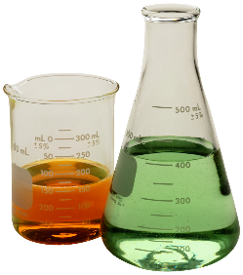
Table 1: Final Results
Label | Density | Current (Amps)
A
B
C

Step 2: Visual Ranking (Qualitative Method)
Using your saltwater circuit, rank the mixtures by how bright the light gets once you insert your electrodes into the water. Rank the three mixtures from lowest to highest and record your results. Fill in Table 2 with your results

Table 2: Visual Rankings
Low | Medium | High

Step 3: Electrical Current Measurements (Quantitative Method)
Using the saltwater circuit, touch each electrode together and record the electric current reading. This is the nominal current reading.

nominal electric current ______________

Using your saltwater circuit and a multimeter, measure the amount of current that can flow through the saltwater. Fill in Table 3 with your results.

Table 3: Electric Current Readings
Label | Current (Amps)
A
B
C

Step 4: Now you have collected all the data needed to perform some analysis.
Make a plot of your electrical current readings vs. density.

