Example Case Study News Article

CU-Boulder, NCAR Awarded $1.5 Million EPA Grant to Study Cooking Pollution

Researchers Will Follow 250 Families in Ghana Using Different Cookstoves
By Sarah Kuta, Daily Camera Staff Writer
Posted: 06/24/2014 06:35:04 AM MDT
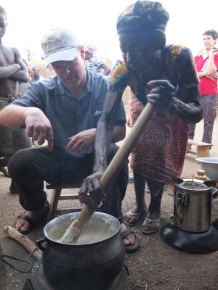
Researchers at the University of Colorado and the National Center for Atmospheric Research plan to measure pollution caused by residential cooking with a new $1.5 million grant from the Environmental Protection Agency.
Exposure to cookstove emissions ranks as one of the top overall health risk factors in developing countries, according to a news release. The World Health Organization estimates that 4.3 million people die prematurely per year from exposure to smoke from cookstoves.
The team, led by associate professor Mike Hannigan, will attempt to reduce women and children's exposure to air pollutants in sub-Saharan Africa by measuring and modeling air quality and climactic impacts of cooking. Researchers began studying 250 households in Ghana on June 1 to measure pollution from cooking, burning trash and car emissions.
University of Colorado Boulder professor Mike Hannigan learns to make a local dish in Ghana. (Photo credit: Mike Hannigan)

Some of the Ghanaian households have been given high-tech cookstoves, while others received less costly cookstoves. A third group will continue cooking over a fire on the ground. Researchers plan to understand the motivating factors behind how the households cook and will measure their health along the way.
The CU grant was part of $9 million in EPA funding that went toward six projects focused on creating cleaner cooking, heating and lighting practices.
///
Source: Sarah Kuta, "CU-Boulder, NCAR awarded $1.5 million EPA grant to study cooking pollution," Daily Camera, Boulder, CO, June 24, 2014.

