Name:



Date:

ADVENTURE ENGINEERING – “Lost in the Amazon” LESSON 3: The Need for Shelter

ACTIVITY 1: Home Sweet Home!

As you begin your journey into the exciting and mysterious Amazon Rainforest, you hear chattering monkeys in the distance. You walk along for about ten minutes and you notice it is very warm and humid even though there is plenty of shade. The pack you are carrying is starting to get a little bit heavier and you wish you were back in the hotel swimming pool. Then, out of nowhere you hear a high-pitched scream coming from behind you. At first you think it is a wild monkey or bird but then you realize that it is only your friend Jennie, an Environmental Engineer.

“Eeeeek, who’s wasting water!?” She yells as you notice everyone looking confused. But before anyone has time to answer, a warm rain begins to pour furiously from the sunny

sky.

“It’s raining, and our supplies are starting to get wet!” Robert, a Civil Engineer, cries out from the back of the group. You quickly realize you need a shelter that is easy to build and can be taken with you. What can you use? How will you build it? There are no umbrellas here!

**Procedures:**

1. Get into groups and discuss a few ideas of some possible designs for a shelter.

What features do you want your shelter to have? (Protection from rain? Wind? Will it have windows? Should it be portable?) Sketch your ideas in the box below.

2. Place the “Amazon Plant Leaves” handout under the wax paper so that you can see the outlines through the paper.

3. Decide which kind of leaves and how many of each you will need to build the

shelter you planned. Trace the leaves you wish to use onto the wax paper. Keep in mind that there is only 1 sheet of wax paper so try to fit the leaves on the sheet carefully.

4. Cut out all the leaves traced on the wax paper.

5. Throw away any left over wax paper.

6. In your team of engineers, decide which design you will use to construct your shelter using only the materials that you have been provided.

7. Using the leaves, kite string, reinforcers and Popsicle sticks create a shelter big enough to hold the cup inside. Use the stickers or tape to connect the string to the leaves. Keep in mind that these shelters will need to be mobile. Make sure that you can fold them up in order to carry them with you on your journey.

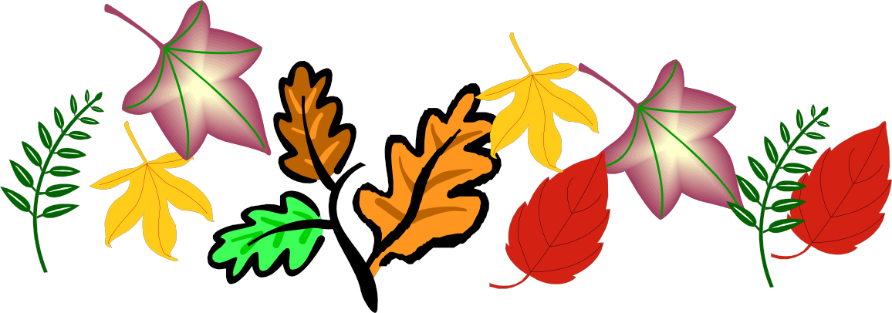

9