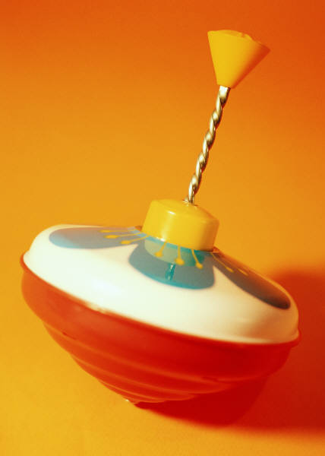
Engineering in Reverse! Activity –
Engineering in Reverse Worksheet
In the box below, complete a detailed drawing of the internal components (i.e,
the inside mechanisms) in the push-toy before it has been disassembled.
Your drawing should include:
- Label for all parts
- Brief description of each part’s function(s)
BEFORE Disassembly

In the box below, complete a detailed drawing of the internal components of the push-toy after it has been disassembled. Your drawing should include:
- Label for all parts
- Brief description of each part’s function(s)
AFTER Disassembly

After you have completed your drawing, answer the following questions.
- What does this device do? What parts make it work this way?
________________________________________________________________________________________________________________________________________________________________________________________________________________________
________________________________________________________________________
________________________________________________________________________
________________________________________________________________________
- How would you improve the way this device is made?
________________________________________________________________________________________________________________________________________________________________________________________________________________________
________________________________________________________________________________________________________________________________________________________________________________________________________________________
- How could you change this device to make it more cost effective to produce?
________________________________________________________________________________________________________________________________________________________________________________________________________________________
________________________________________________________________________________________________________________________________________________________________________________________________________________________
- Can you redesign this device to make it function differently? How would you do this?
________________________________________________________________________________________________________________________________________________________________________________________________________________________
________________________________________________________________________________________________________________________________________________________________________________________________________________________

