**Red Cabbage Chemistry Worksheet**

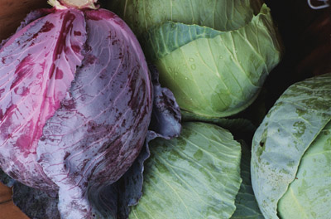Red cabbage juice contains a natural pH indicator that changes colors depending on the acidity of the solution. The pigment in red cabbage that causes the red color is called **flavin**. Flavin is a water-soluble pigment also found in apple skins, plums, and grapes. Very acidic solutions turn the indicator **red**, neutral solutions turn the indicator **purple**, and basic solutions turn the indicator a **greenish-yellow** color.

For environmental and chemical engineers, the pH values of different liquids and solutions are important to consider, especially as they relate to bodies of water and explain the behavior of minerals and chemicals. For example, at acidic pH values, water begins to cause harm and destruction of ecosystems and minerals, as evidenced by acidic water dissolving the calcium carbonate that forms mollusk shells.

**Reference Information**

|  |  |
| --- | --- |
| acids = low pH (0-7) | bases = high pH (7-14) |

**Cabbage Indicator**

|  |  |
| --- | --- |
| **Cabbage Color** | **pH** |
| **red** | **2** |
| **purple** | **4** |
| **violet** | **6** |
| **blue** | **8** |
| **blue-green** | **10** |
| **greenish-yellow** | **12** |

*Red cabbage photo source*: Hanford Site, WA, US Dept. of Energy, <http://hanford-site.pnnl.gov/envreport/2001/summonitor.stm>

**Data Gathering**

1. Pour a small amount of the red cabbage indicator liquid into each of the seven cups of different liquids. Add just enough indicator until you see a color change. Record your observations, and rank them based on their pH, using this scale:

**1 = lowest pH, 7 = highest pH**

|  |  |  |  |
| --- | --- | --- | --- |
| **Solution** | **Color** | **Cabbage Color pH** | **Ranking** |
| **lemon juice** |  |  |  |
| **baking soda** |  |  |  |
| **milk** |  |  |  |
| **vinegar** |  |  |  |
| **soda** |  |  |  |
| **Windex** |  |  |  |
| **water** |  |  |  |

1. Use pH-indicator strips to measure and record the pH values in the table below.

|  |  |  |
| --- | --- | --- |
| **Solution** | **Strip Color** | **pH** |
| **lemon juice** |  |  |
| **baking soda** |  |  |
| **milk** |  |  |
| **vinegar** |  |  |
| **soda** |  |  |
| **Windex** |  |  |
| **water** |  |  |

**Analysis Questions**

1. How did your cabbage pH indicator values compare to pH indicator strip values?
2. What other acids and bases do we encounter every day?
3. For what other liquids are you curious about their pH values?