Introduction to Friction

Instructions: Read the following text and complete the worksheet. The estimated reading time is 2-3 minutes.

It is impossible to go through a normal day and not encounter friction. We define friction as a force that resists the relative motion of two surfaces. Think of friction as the force that helps you keep hold of objects and prevents them from slipping through your hands. Friction is the force that helps you not slip and fall in the bathroom and helps you clean your teeth when brushing. The friction between the wheels of the school bus and the road helps the bus driver get you to school safely. When you are writing, you move a pencil across the paper and friction removes the graphite in your pencil.

In industry, we use various machines with numerous moving parts and interacting surfaces where friction occurs. We spend a lot of energy to overcome friction, and a lot of money to maintain or replace worn parts due to wear. Reducing friction will significantly reduce global energy consumption and CO₂ emissions. But is it always beneficial to reduce friction?

Engineers use many strategies to control friction. One strategy is to use lubricants. A lubricant is a substance that helps reduce friction. A common example of lubrication is when we oil the hinges on a door to prevent it from creaking. You might lubricate your bike chain to help it function more smoothly. Another strategy is to modify the surfaces in contact. This can be achieved either by designing the surfaces themselves or by coating them with other materials. For example, engineers have developed computational models that simulate how shoe treads interact with the floor. This helps them test various materials and new tread designs and measure their traction. Inspired by kirigami, a variation of origami, researchers have created flat sheets that attach to the sole of the shoe. While standing, these sheets remain flat, but spikes pop out when the shoe is stretched in every step.

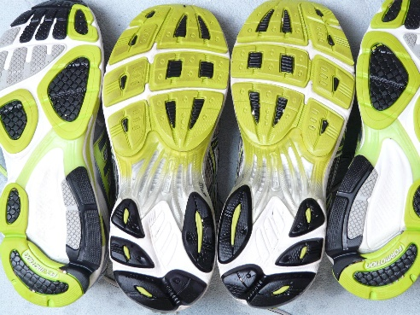
Example of shoe tread patterns (image source)

Although we can’t escape friction, we have many tools in our toolbox to modify and control friction.
In your group, discuss what you already knew about friction that did not appear in the text. Summarize your discussion here:
In your group, discuss what you took away from the text. Use the space below to organize your thoughts, ask questions, and document your aha moments.
Thoughts: | Questions: |  | Epiphanies:
In your group, brainstorm and list situations where you think friction is beneficial
and situations where friction is undesirable.
Beneficial: |  | Undesirable:

In your group, list common types of surfaces you encounter daily and then order them in a list.
Which surface do you think is the smoothest?
Types of surfaces encountered daily: | Order these surfaces by smoothness:  - ____________________________  - ____________________________  - ____________________________  - ____________________________  - ____________________________

